Astrodon System Guide

Table of Contents

1: System 5

1.1) System Configuration: 5

1.2) System Building: 6

Add New Building: 6

Building Details: 7

Financials: 8

Insurance: 9

PDF Viewer: 9

1.3) Building Maintenance Configuration: 10

1.4) Bank Configuration: 11

1.5) Users: 12

1.6) Bulk SMS: 13

1.7) Management Pack TOC Descriptions: 13

1.8) Public Holidays: 13

2: Reporting 14

2.1) Summary: 14

2.2) SMS: 14

2.3) Email: 15

2.4) PA / PM: 15

2.5) Statement Run: 16

2.6) Trust: 17

2.7) Supplier Report: 17

2.8) Maintenance Report: 18

2.9) Insurance Schedule: 18

3: Processing 19

3.1) Rental Imports: 19

3.2) Letters: 19

3.3) Clearances: 20

3.4) Bulk Statements: 20

3.5) Individual Statements: 21

3.6) Journals: 22

3.7) Credits: 23

3.8) Monthly / Periodic: 23

4: Customers 24

4.1) Customer File: 24

4.2) Email Customer: 29

4.3) Search Customers: 30

4.4) SAPOR Debit Order: 30

5: PM/PA 32

5.1) New Job: 32

5.2) Job List: 34

5.3) Web Maintenance: 35

5.4) Bulk Email: 36

5.5) Management Report: 37

5.6) Requisitions: 38

Payment Requisitions 38

Requisition Log 40

Missing Maintenance Requisitions 41

Supplier Bulk Requisition 42

Download Requisition Batch 44

Unpaid Requisitions 45

Nedbank Beneficiary Maintenance: 46

5.7) Building Maintenance: 46

5.8) Supplier Maintenance: 46

5.9) Insurance Broker Maintenance: 48

6: Debtors Reports 50

6.1) Debtors Report: 50

6.2) Consolidated Debtors Report: 51

7: Reminders 52

8: Monthly Financials 53

8.1) Checklist: 53

8.2) Report: 56

8.3) Request Allocations: 57

8.4) Levy Roll: 57

8.5) Management Pack: 58

8.6) Publish Management Pack: 59

8.7) Calendar: 59

# 1: System

## 1.1) System Configuration:

|  |  |  |
| --- | --- | --- |
| Input: | Sample: | Notes: |
| Minimum Balance: | 100.00 |  |
| Standard Reminder Fee: | 68.54 |  |
| Standard Final Demand Fee: | 114.24 |  |
| Standard Summons Fee: | 205.64 |  |
| Standard Disconnect Notice Fee: | 83.78 |  |
| Standard Disconnect Fee: | 833.72 |  |
| Standard Handover Fee: | 381.13 |  |
| Clearance Fee: | 872.42 |  |
| Extended Clearance Fee: | 476.41 |  |
| Clearance Recon Split Fee: | 464.50 |  |
| Debit Order Fee: | 41.54 |  |
| Returned Debit Order Fee: | 208.43 |  |
| EFT Fee: | 9.55 |  |
| Monthly Building Journal Fee: | 115.96 |  |
| Cash Deposit Fees: |  |  |
| Trust Acc: | TRUST18 |  |
| Business Acc: | ASTROD18 |  |
| Centrec Acc: | CENTRE18 |  |
| Rental Acc: | PROREN18 |  |

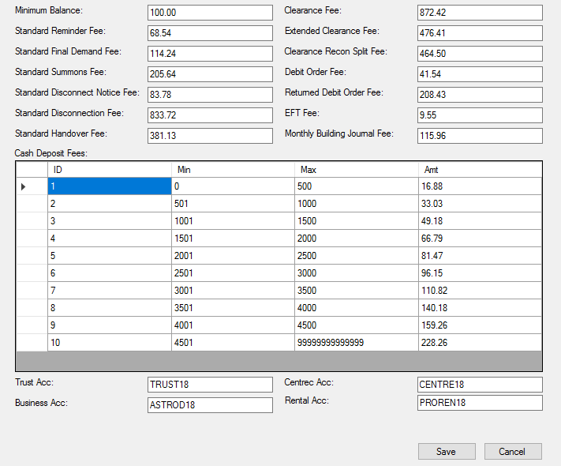

Figure 1: System Configuration

## 1.2) System Building:

### Add New Building:

Building Details:

|  |  |  |
| --- | --- | --- |
| Input: | Sample: | Notes: |
| ID: | 212 |  |
| Building Name: | 155 Smit Street B/C |  |
| Letter Name: | 155 Smit Street B/C |  |
| Trust Account: | 9364000 |  |
| Data Path: | SMITHS17 |  |
| Cash Book Account: | 8400/000 |  |
| Payment Limit (Month): | 250.000.00 |  |
| Period (Behind Trust): | 4 |  |
| Payment Type: | 1 |  |
| Receipt Type: | 2 |  |
| Journal Type: | 7 |  |
| Address: | 155 Smit Street Braamfontein |  |
| Account Name: | Astrodon Trust Acc |  |
| Branch Code: | 190242 |  |
| Centrec in Building: | 9250/000 |  |
| Account in Business: | DFC-15 |  |
| Own Bank Account: |  |  |
| PM: | Pm2@astrodon.co.za |  |
| Bank Name: | Nedbank |  |
| Bank Account Number: | 1902226429 |  |
| Is a Web Building: | Select it is a Web Building |  |
| Abbr/Code: | SMT |  |
| Account in Centrec/Investment Account: | SMT |  |
| Bank: | Select One In Dropdown  8410/000 |  |
| Payment Limit (Day): | 0.00 |  |
| Reminder Fee: | 68.54 |  |
| Final Demand Fee: | 114.24 |  |
| Discount Notice Fee: | 83.78 |  |
| Summons Fee: | 205.64 |  |
| Disconnection Fee: | 833.72 |  |
| Handover Fee: | 381.13 |  |
| Reminder Split: | 0 |  |
| Final Demand Split: | 0 |  |
| Disconnect Notice Split: | 0 |  |
| Summons Split: | 0 |  |
| Disconnection Spilt: | 0 |  |
| Handover Split: | 0 |  |
| Debit Order Fee: | 25.00 |  |
| Disable Debit Order Fee: | Select if you want to disable |  |
| Trustees | Select accounts which are trustees |  |

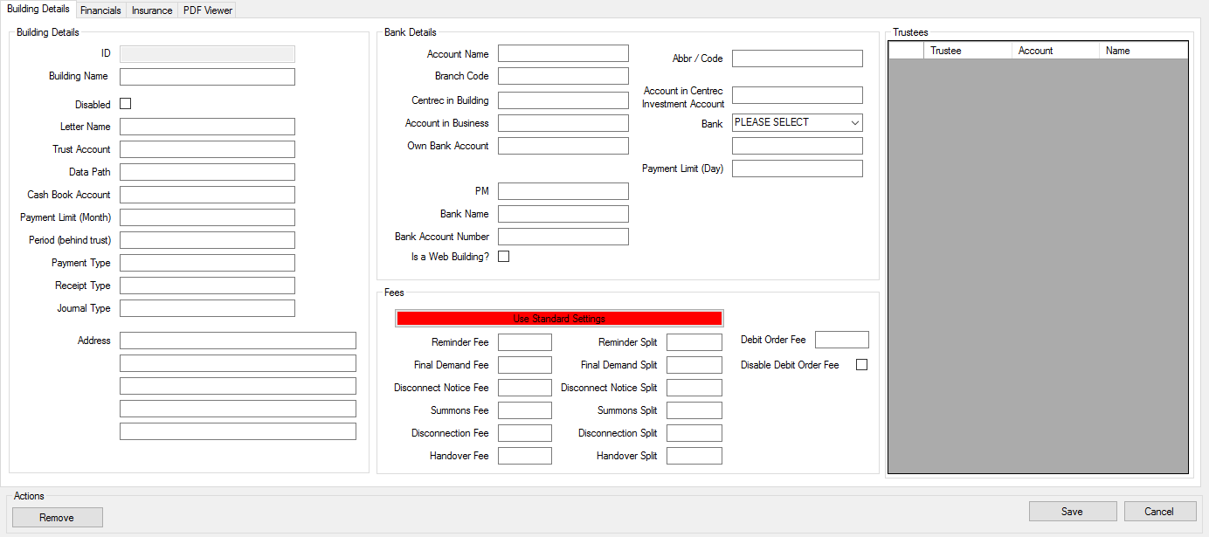

Figure 2: Add New Building

### Building Details:

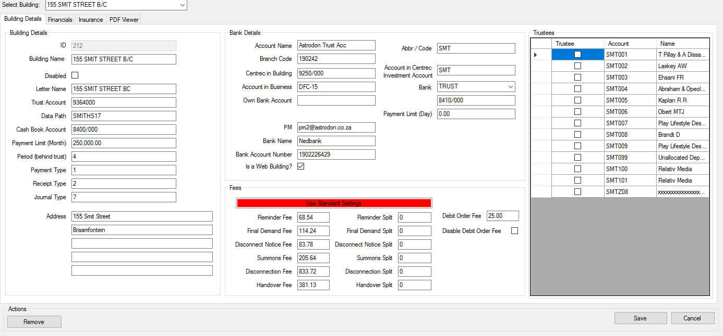

Figure 3: Building Details

### Financials:

|  |  |  |
| --- | --- | --- |
| Input: | Sample: | Notes: |
| Building Financials Enabled: | Select/Deselect |  |
| Financial Start Date: | 2017/12/11 |  |
| Financial End Date: | Select/Deselect |  |
| Fixed: | Select/Deselect |  |
| Day To Be Completed: | 1 |  |
| Fixed Monthly Financial Meeting: | Select/Deselect |  |
| Day: | 2 |  |
| Notify Trustees: | Select/Deselect |  |
| Start: | 12:30:55PM |  |
| End: | 12:45:55PM |  |
| Event: | AGM |  |
| Venue: | Board Room Main |  |
| BCC: | [willie@mail.com](mailto:willie@mail.com) |  |
| Invite Subject: | Fixed Scheduled Meeting |  |
| Invite Body Content: | This is the body content for this meeting |  |

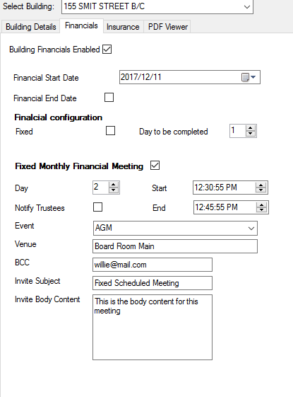

Figure 4: Financials

### Insurance:

|  |  |  |
| --- | --- | --- |
| Input: | Sample: | Notes: |
| Common Property Dimensions: | 5000.00 |  |
| Unit Property Dimensions: | 4000.00 |  |
| Replacement Value: | 10.000.000.00 |  |
| Includes Common Property: | Select/Deselect |  |
| Common Property Value: | 200.000.00 |  |
| Bond Holder Interest Noted: | Select/Deselect |  |
| Bond Originator: |  |  |
| Policy Number: | 12345 |  |
| Select Broker: | Santam 22 |  |

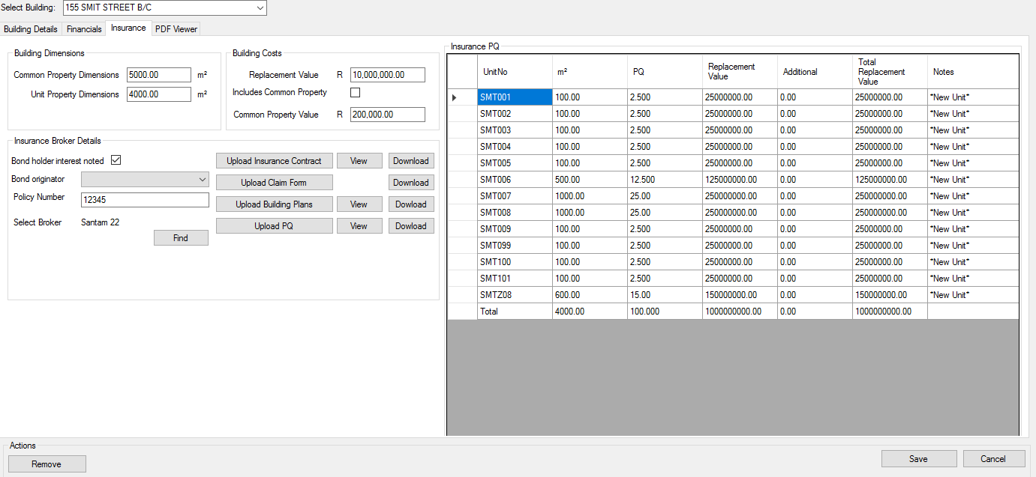

Figure 5: Insurance

### PDF Viewer:

Under Insurance you can view the Insurance contract, Building plans and PQ. If you select view, this will show in PDF Viewer.

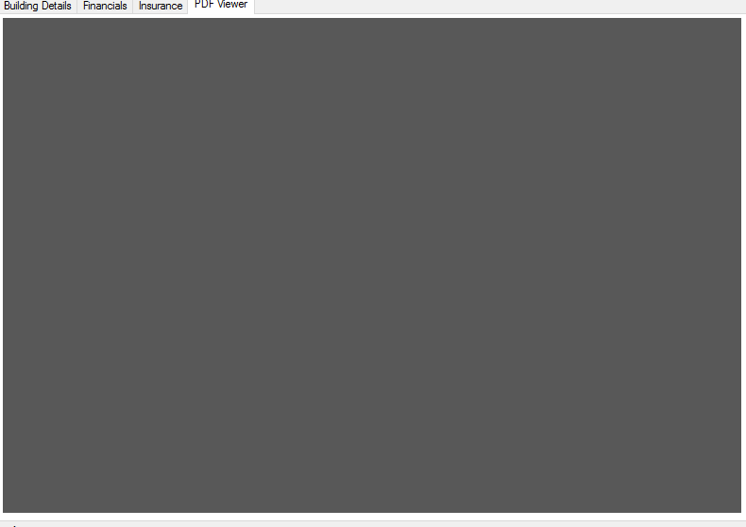

Figure 6: PDF Viewer

## 1.3) Building Maintenance Configuration:

|  |  |  |
| --- | --- | --- |
| Input: | Sample: | Notes: |
| Select Building: | 155 SMIT STREET B/C |  |
| Select Account: | 1000000 – Levies Received |  |
| Name: |  |  |
| Classification: | Remedial Maintenance/Insurance/Maintenance Plan/Project |  |

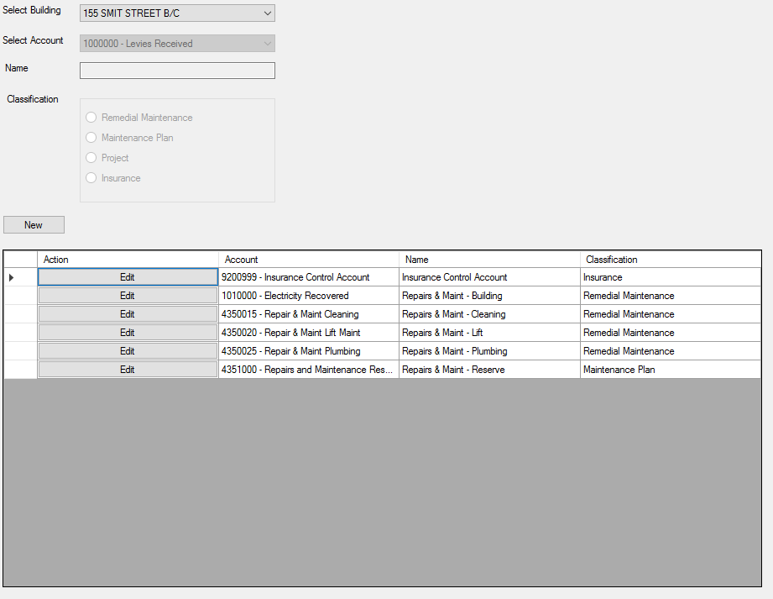

Figure 7: Building Maintenance Configuration

## 1.4) Bank Configuration:

|  |  |  |
| --- | --- | --- |
| Input: | Sample: | Notes: |
| Name: |  |  |
| Universal Branch Name: | ABSA |  |
| Universal Branch Code: | 123 |  |
| Active: | Select/Deselect |  |

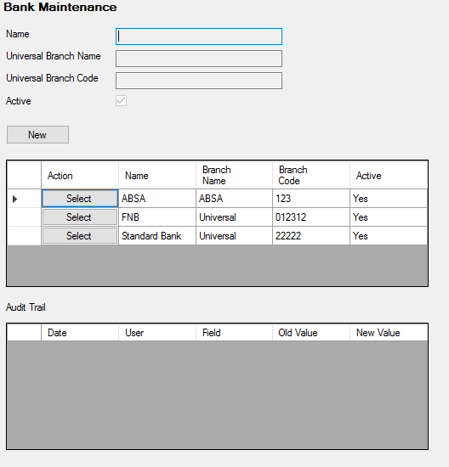

Figure 8: Bank Configuration

## 1.5) Users:

|  |  |  |
| --- | --- | --- |
| Input: | Sample: | Notes: |
| Select User: | Priscilla Manjonjo |  |
| User ID: | 15 |  |
| User Name: | Priscilla |  |
| Email: | [rental01@astrodon.co.za](mailto:rental01@astrodon.co.za) |  |
| Phone: | 011 867 3183 ext 115 |  |
| User Type: | Debtor |  |
| Password: | Any |  |
| Name: | Priscilla Monjonjo |  |
| Fax: | 0866682026 |  |
| Check Lists: | Select/Deselect |  |
| Signature: | Uploaded image of signature. |  |
| Linked Buildings: | Buildings user has access to. |  |

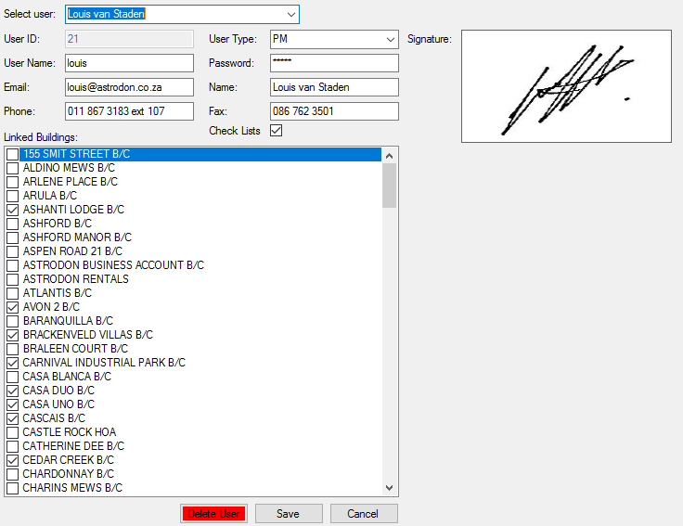

Figure 9: Users

## 1.6) Bulk SMS:

|  |  |  |
| --- | --- | --- |
| Input: | Sample: | Notes: |
| Select Building: | 155 SMIT STREET B/C |  |
| Select / Deselect All | Select/Deselect |  |

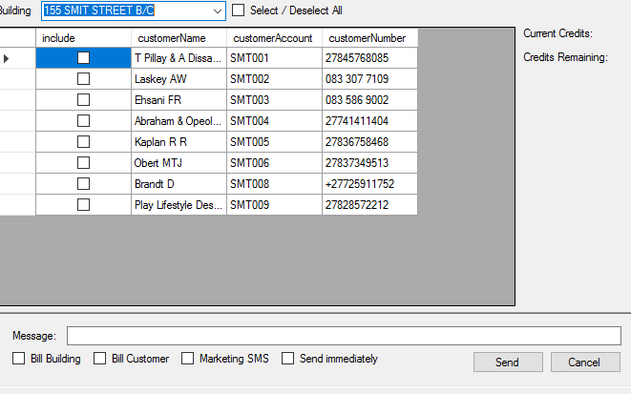

Figure 10: Bulk SMS

## 1.7) Management Pack TOC Descriptions:

Here the user can define different sections for the management pack Table of Contents.

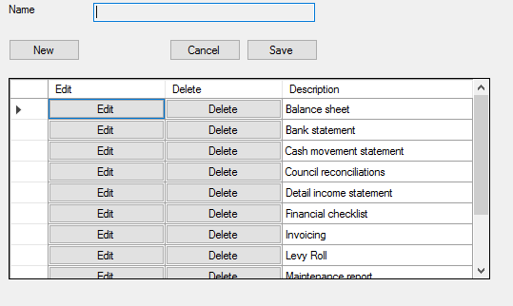

Figure 11: Management Pack TOC Descriptions

## 1.8) Public Holidays:

|  |  |  |
| --- | --- | --- |
| Input: | Sample: | Notes: |
| Name: | Christmas |  |
| Date: | 2017/12/25 |  |

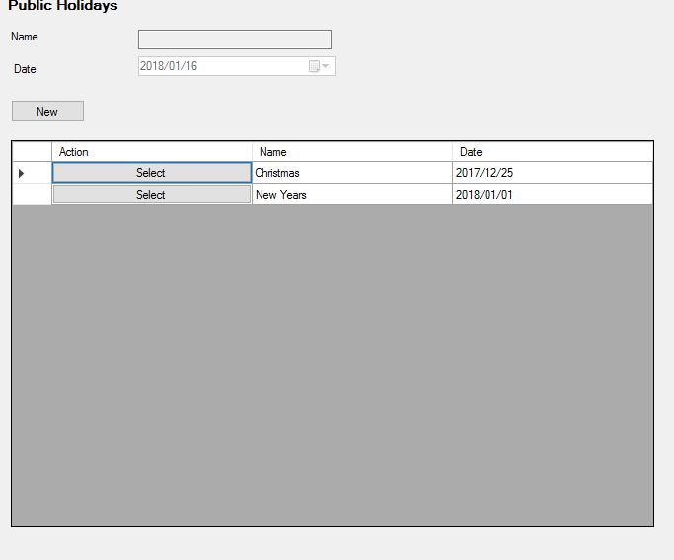

Figure 12: Public Holidays

# 2: Reporting

## 2.1) Summary:

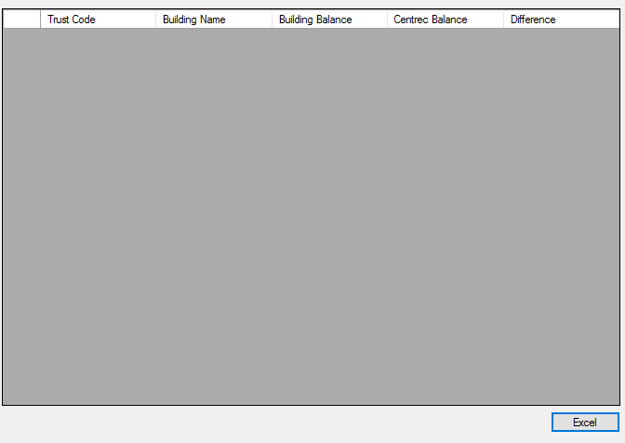

Figure 13: Summary

## 2.2) SMS:

## 2.3) Email:

|  |  |  |
| --- | --- | --- |
| Input: | Sample: | Notes: |
| Search: | Letters |  |
| Search By: | Delivery Status |  |
| Unit: | No Email Address |  |

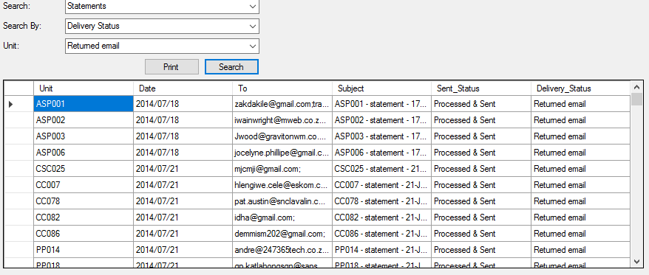

Figure 14: Email

## 2.4) PA / PM:

|  |  |  |
| --- | --- | --- |
| Input: | Sample: | Notes: |
| View By: | Status |  |
| Status: | NEW |  |
| From: | 2017/12/18 |  |
| To: | 2018/01/18 |  |
| Total Jobs: | 2 |  |
| Total Assigned Delay: | 0 |  |
| Avg Assigned Delay: | 0.00 |  |
| Total Completed Delay: | 0 |  |
| Avg Completed Delay: | 0.00 |  |

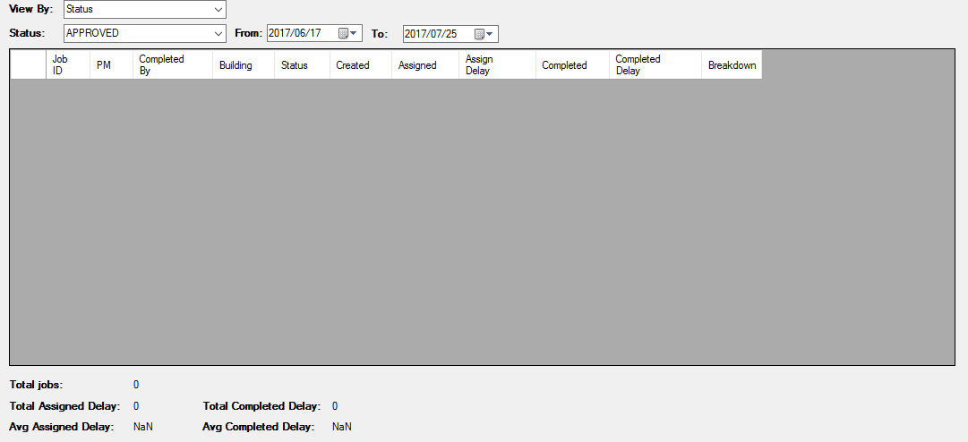

Figure 15: PA/PM

## 2.5) Statement Run:

|  |  |  |
| --- | --- | --- |
| Input: | Sample: | Notes: |
| Select Building: | 155 SMIT STREET B/C |  |
| Sent/Unsent/Both: | Sent |  |
| Date From: | 2017/01/01 |  |
| Date To: | 2018/01/01 |  |
| Statement Count: | 44 |  |

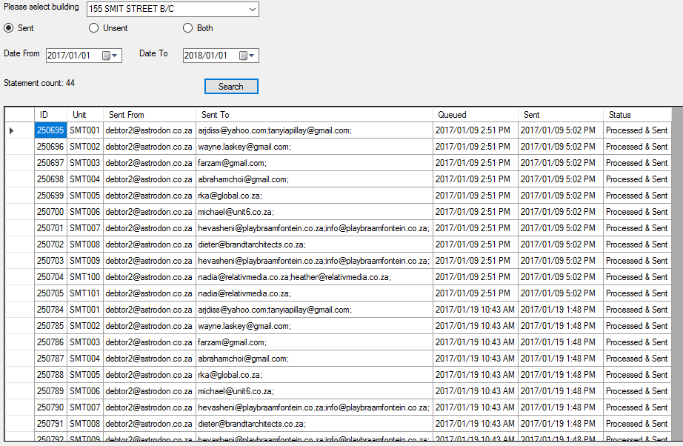

Figure 16: Statement Run

## 2.6) Trust:

|  |  |  |
| --- | --- | --- |
| Input: | Sample: | Notes: |
| Select Building: | 155 SMIT STREET B/C |  |
| From: | 2017/01/01 |  |
| To: | 2018/01/01 |  |

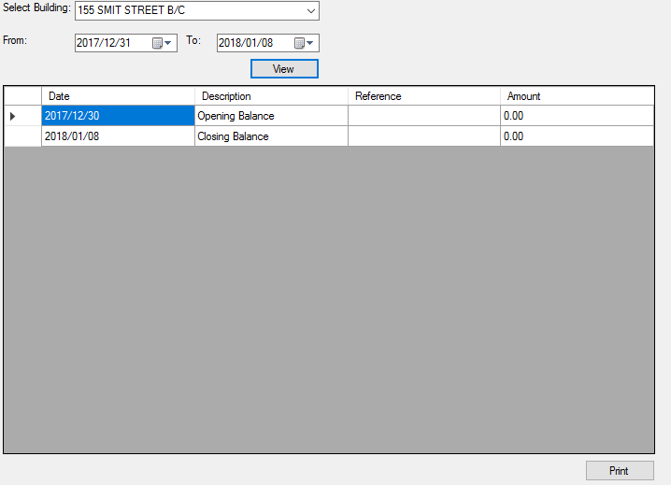

Figure 17: Trust

## 2.7) Supplier Report:

|  |  |  |
| --- | --- | --- |
| Input: | Sample: | Notes: |
| From: | 2017/01/01 |  |
| To: | 2017/12/01 |  |
| Building: | 155 SMIT STREET B/C |  |
| Company Name: | Astrodon Pty Ltd |  |
| Company Reg#: | 2004/003502/07 |  |
| Contact Person: | Sheldon Terry |  |
| Contact Number: | 0118673183 |  |

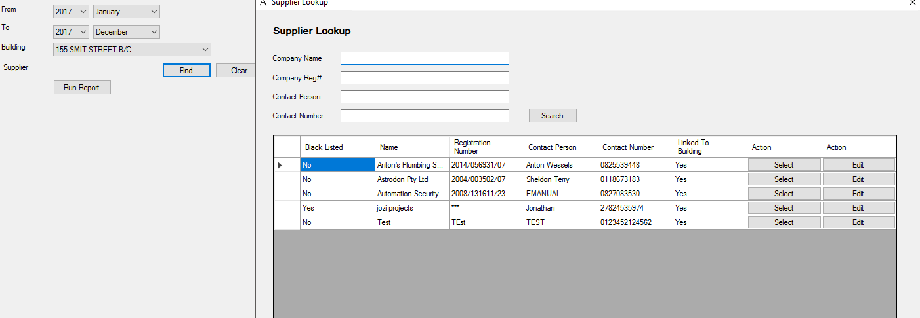

Figure 18: Supplier Report

## 2.8) Maintenance Report:

|  |  |  |
| --- | --- | --- |
| Input: | Sample: | Notes: |
| Building: | 155 SMIT STREET B/C |  |
| From: | 2017/01/01 |  |
| To: | 2018/01/01 |  |
| Report Type: | Detailed Report with Supporting Documents |  |

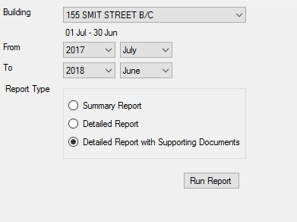

Figure 19: Maintenance Report

## 2.9) Insurance Schedule:

|  |  |  |
| --- | --- | --- |
| Input: | Sample: | Notes: |
| Building: | 155 SMIT STREET B/C |  |

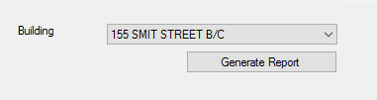

Figure 20: Insurance Schedule

# 3: Processing

## 3.1) Rental Imports:

|  |  |  |
| --- | --- | --- |
| Input: | Sample: | Notes: |
| Select File: |  |  |
| Period: | 5 |  |

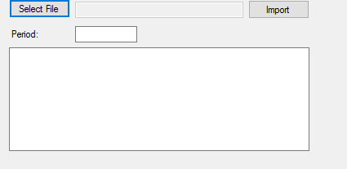

Figure 21: Rental Imports

## 3.2) Letters:

|  |  |  |
| --- | --- | --- |
| Input: | Sample: | Notes: |
| Select Building: | 155 SMIT STREET B/C |  |
| Select Category: | 00-Standard |  |
| Disconnect Date: | 2017/06/01 |  |

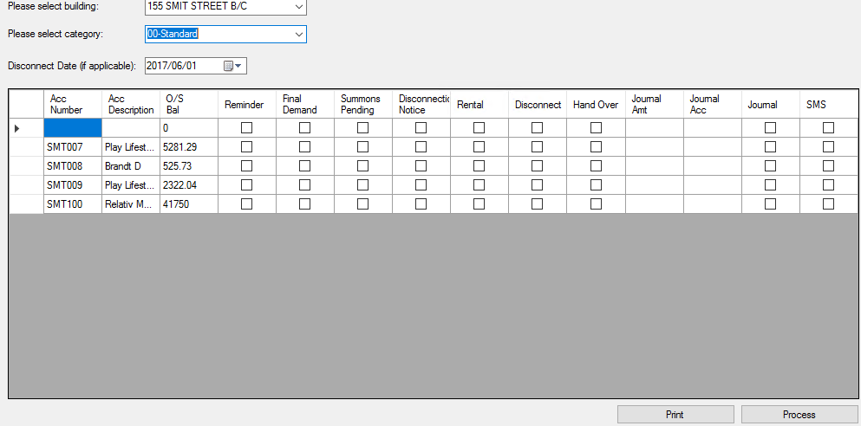

Figure 22: Letters

## 3.3) Clearances:

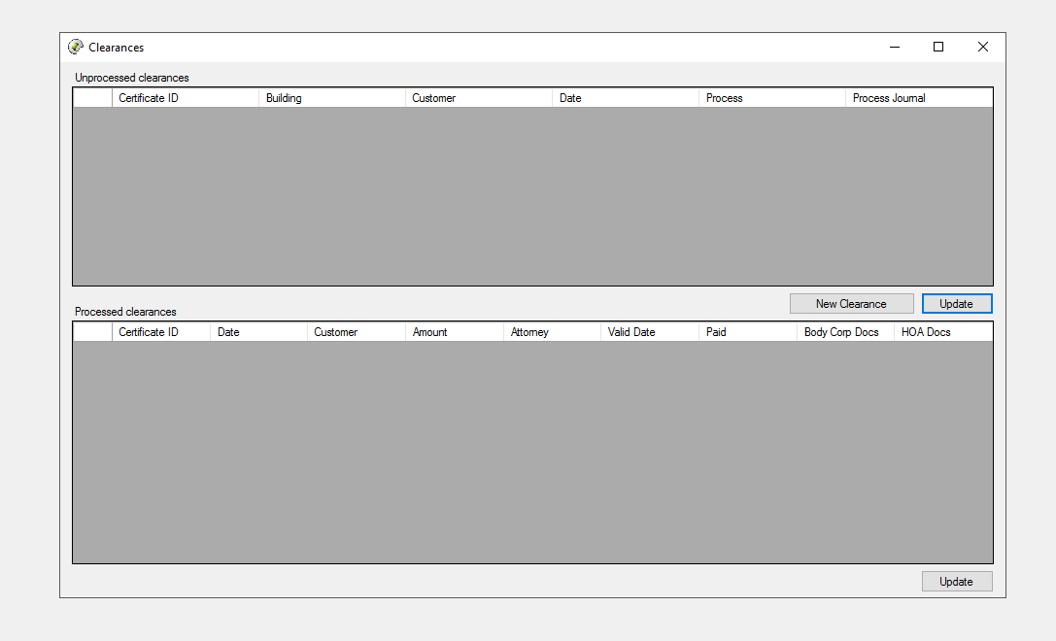

Figure 23: Clearances

## 3.4) Bulk Statements:

|  |  |  |
| --- | --- | --- |
| Input: | Sample: | Notes: |
| Select / Deselect All: | Select/Deselect |  |
| Statement Date: | 2017/01/01 |  |
| Additional Message To Be Displayed On Statement: |  |  |
| Add Attachment: |  |  |

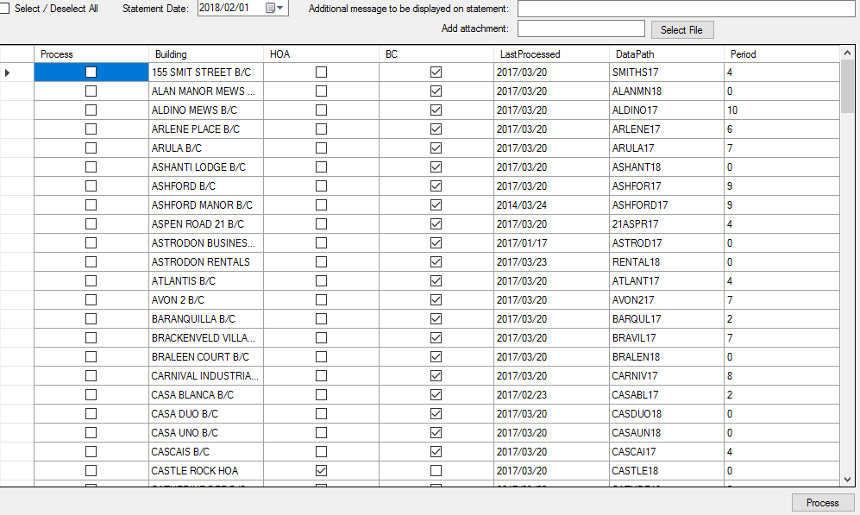

Figure 24: Bulk Statements

## 3.5) Individual Statements:

|  |  |  |
| --- | --- | --- |
| Input: | Sample: | Notes: |
| Statement Date: | 2017/06/01 |  |
| Select Building: | 155 SMIT STREET B/C |  |
| Select Customer: | SMT101 |  |
| Additional Message: |  |  |
| Attachment: |  |  |
| Transactions: |  |  |

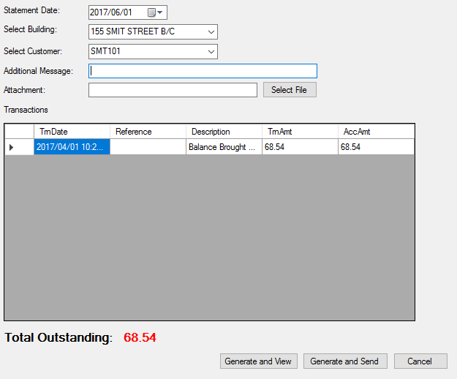

Figure 25: Individual Statements

## 3.6) Journals:

|  |  |  |
| --- | --- | --- |
| Input: | Sample: | Notes: |
| Select Building: | 155 SMIT STREET B/C |  |
| Select Customer: | SMT004 |  |
| Transaction Date: | 2017/01/01 |  |
| Reference: |  |  |
| Description: |  |  |
| Centrec Contra: |  |  |
| Amount: |  |  |

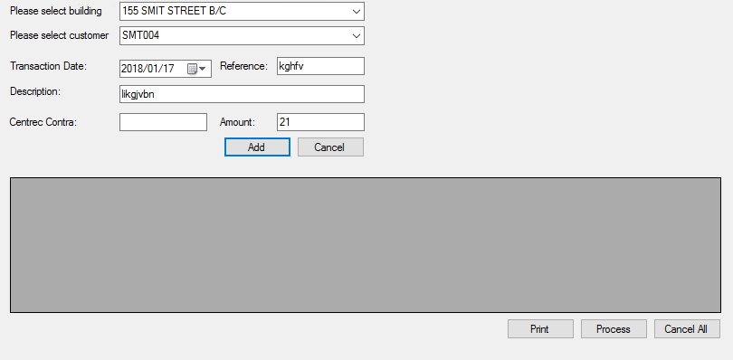

Figure 26: Journals

## 3.7) Credits:

|  |  |  |
| --- | --- | --- |
| Input: | Sample: | Notes: |
| Select Building: | 155 SMIT STREET B/C |  |

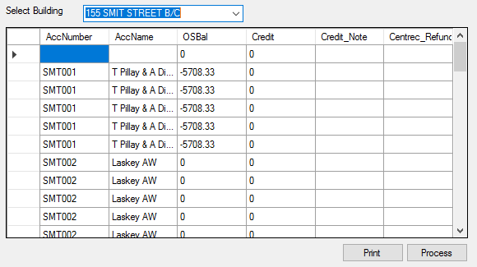

Figure 27: Credits

## 3.8) Monthly / Periodic:

Print Envelopes:

|  |  |  |
| --- | --- | --- |
| Input: | Sample: | Notes: |
| Select Paper Size: | A4 |  |
| Select Building: | 155 SMIT STREET B/C; AVON 2 B/C |  |

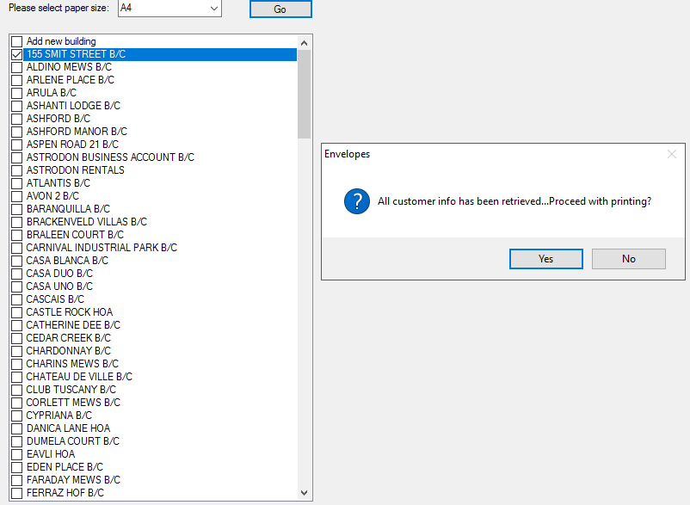

Figure 28: Monthly / Periodic

# 4: Customers

## 4.1) Customer File:

|  |  |  |
| --- | --- | --- |
| Input: | Sample: | Notes: |
| Select Building: | 155 SMIT STREET B/C |  |
| Select Customer: | SMT008 |  |
| Account Number: | SMT008 |  |
| Current Category: | None/Standard |  |
| Description: | Brandt D |  |
| New Category: | None/Standard |  |
| Address: | Unit 008 – Smit Street B/C  Section 9  155 Smit Street  Braamfontein  2001 |  |
| Telephone: |  |  |
| Fax: |  |  |
| Contact: | Dieter |  |
| Cell Phone: | +27725911752 |  |
| Email: | dieter@brandtarchitects.co.za |  |

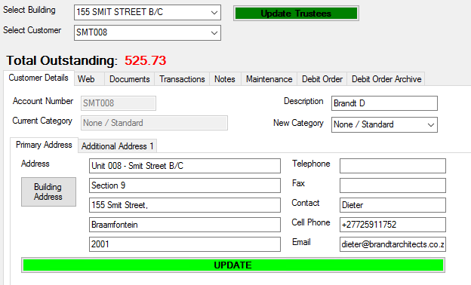

Figure 29: Customer File - Customer Details

|  |  |  |
| --- | --- | --- |
| Input: | Sample: | Notes: |
| Login: |  |  |
| Password: |  |  |
| Linked Units: |  |  |

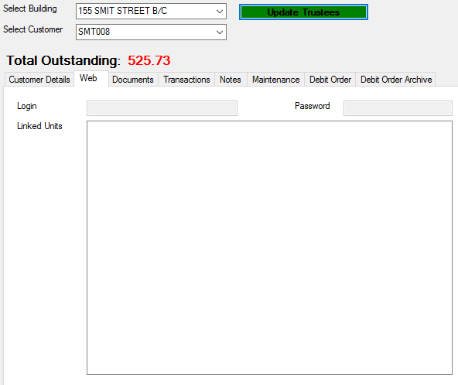

Figure 30: Customer File – Web

|  |  |  |
| --- | --- | --- |
| Input: | Sample: | Notes: |
| Documents: |  |  |
| Send Documents To: | [dieter@brandtarchitects.co.za](mailto:dieter@brandtarchitects.co.za) |  |

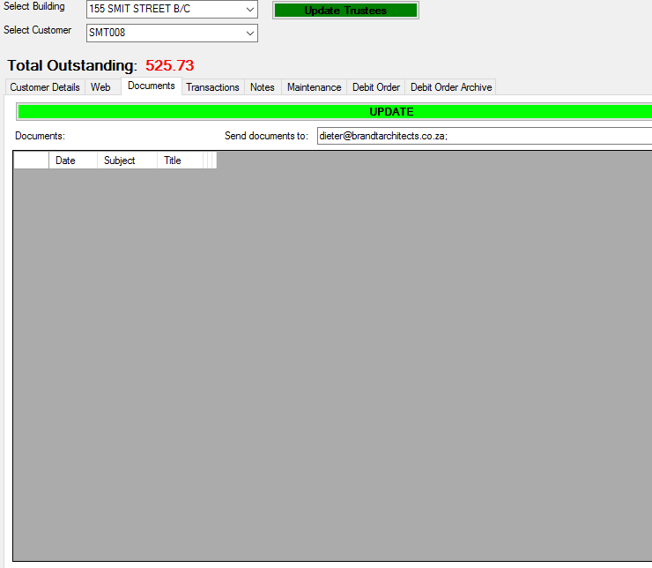

Figure 31: Customer File - Documents

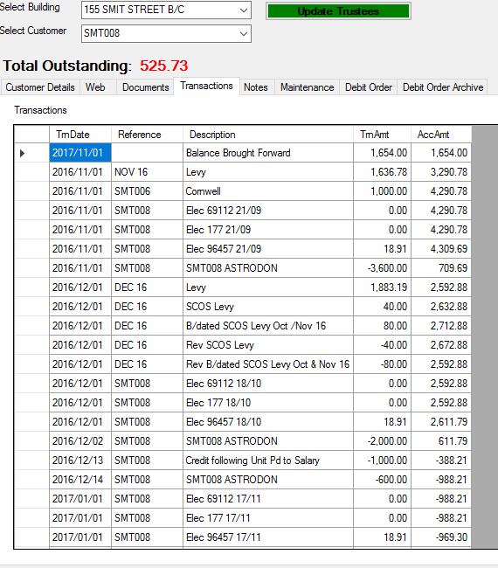

Figure 32: Customer File - Transactions

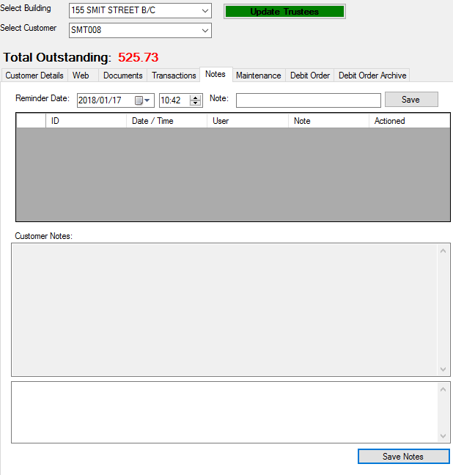

Figure 33: Customer File - Notes

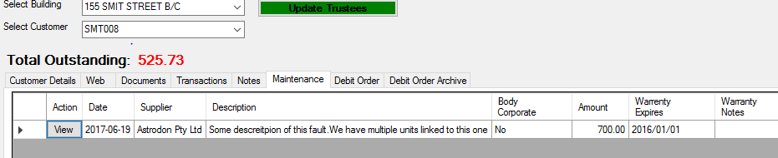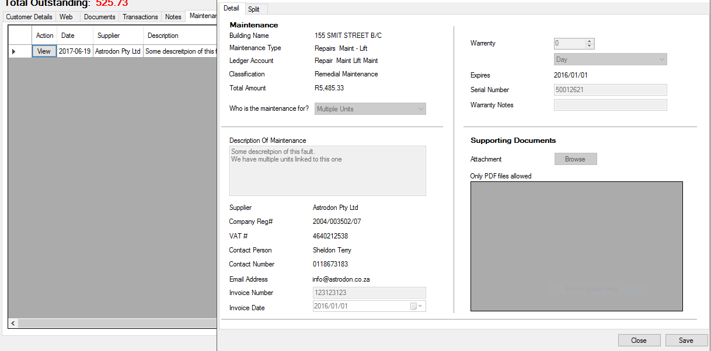

Figure 34: Customer File - Maintenance

|  |  |  |
| --- | --- | --- |
| Input: | Sample: | Notes: |
| Debit Order Enabled: | Select/Deselect |  |
| Disable Debit Order Fee: | Select/Deselect |  |
| Bank: | ABSA |  |
| Branch Code: | 123 |  |
| Account Number: |  |  |
| Account Type: | Cheque |  |
| Process Date: | Fifteen |  |
| Max Amount: |  |  |
| Debit Order Cancelled: | Select/Deselect |  |

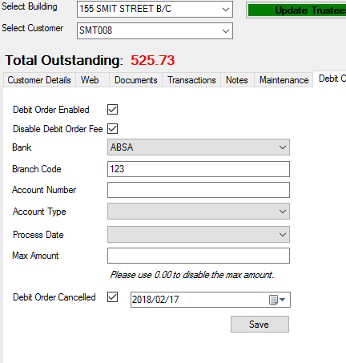

Figure 35: Customer File - Debit Order

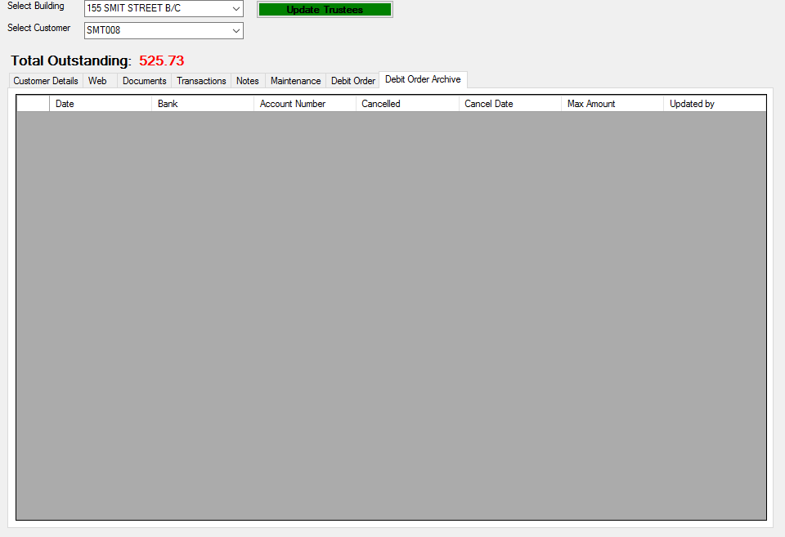

Figure 36: Customer File - Debit Order Archive

## 4.2) Email Customer:

|  |  |  |
| --- | --- | --- |
| Input: | Sample: | Notes: |
| Select Building: | 115 SMIT STREET B/C |  |
| Select Customer: | SMT007 |  |
| Customer Name: | Play Lifestyle Design PTY LTD |  |
| Email Addresses: | [hevasheni@playbrramfontein.co.za](mailto:hevasheni@playbrramfontein.co.za);  [info@playbraamfontein.co.za](mailto:info@playbraamfontein.co.za) |  |
| CC: |  |  |
| BCC: | [Pm2@astrodon.co.za](mailto:Pm2@astrodon.co.za) |  |
| Subject: |  |  |
| Message: |  |  |
| Attachments: |  |  |

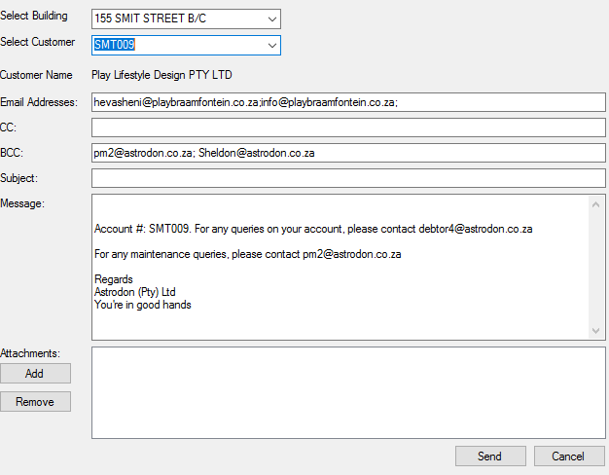

Figure 37: Email Customer

## 4.3) Search Customers:

|  |  |  |
| --- | --- | --- |
| Input: | Sample: | Notes: |
| Building: | 115 SMIT STREET B/C |  |
| Customer Name: |  |  |
| Email Address: | S |  |

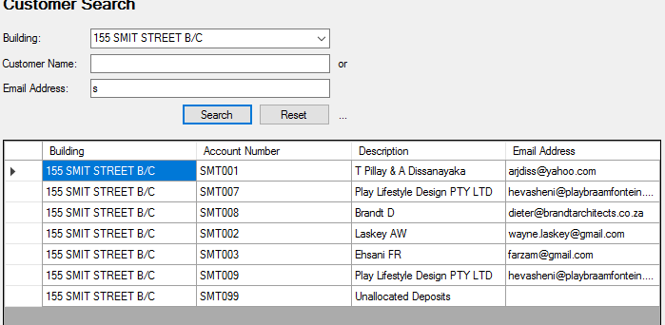

Figure 38: Search Customer

## 4.4) SAPOR Debit Order:

|  |  |  |
| --- | --- | --- |
| Input: | Sample: | Notes: |
| Year: | 2017 |  |
| Month: | December |  |
| Building: | All Buildings |  |
| Show Breakdown: | Select/Deselect |  |

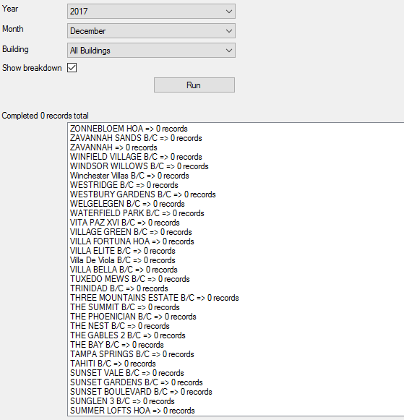

Figure 39: SAPOR Debit Order

# 5: PM/PA

## 5.1) New Job:

|  |  |  |
| --- | --- | --- |
| Input: | Sample: | Notes: |
| Select Building: | 155 SMIT STREET B/C |  |
| Upload To: | Building/Inbox |  |
| Web Folder: |  |  |
| Send To: | All Customers/Selected Customers/Trustees |  |
| Topic/Subject: |  |  |
| Instructions: |  |  |
| Notes: |  |  |

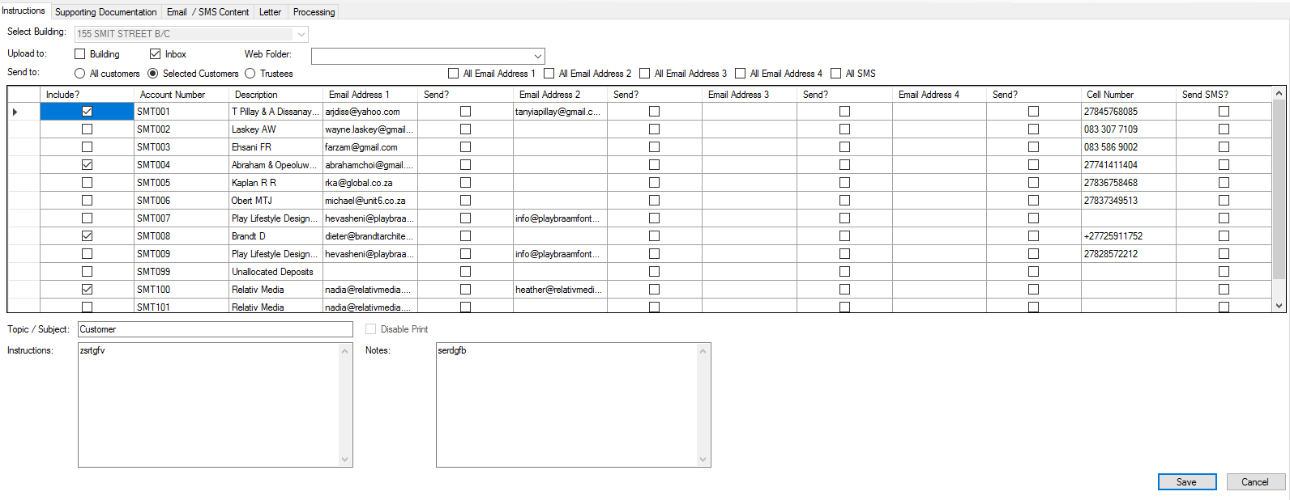

Figure 40: New Job - Instructions

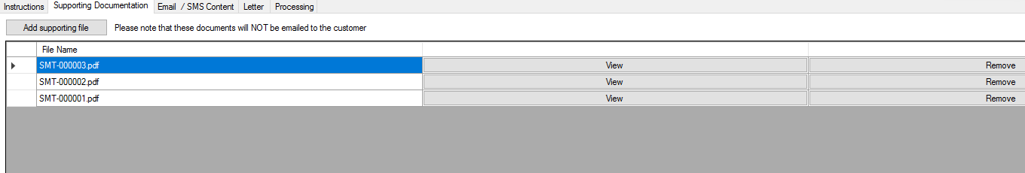

Figure 41: New Job - Supporting Documentation

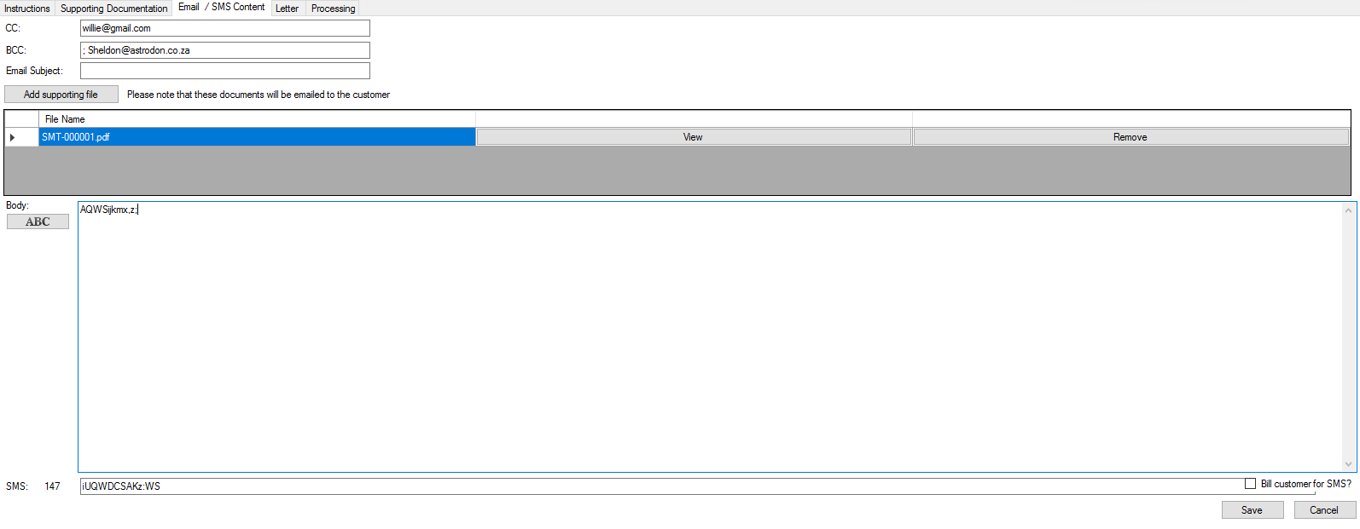

Figure 42: New Job - Email/SMS Content

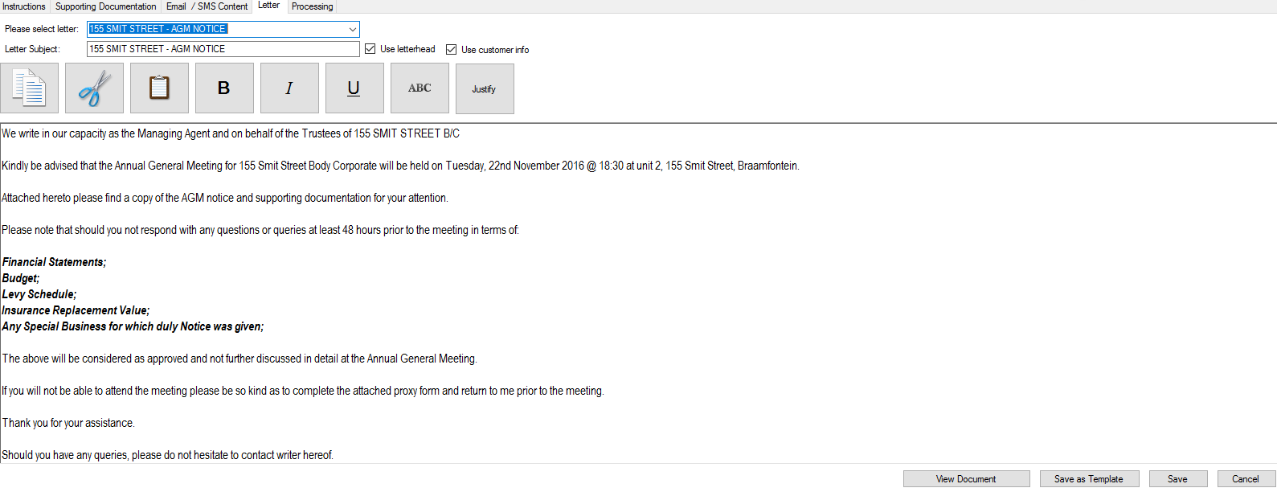

Figure 43: New Job - Letter

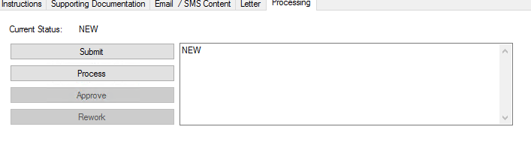

Figure 44: New Job - Processing

## 5.2) Job List:

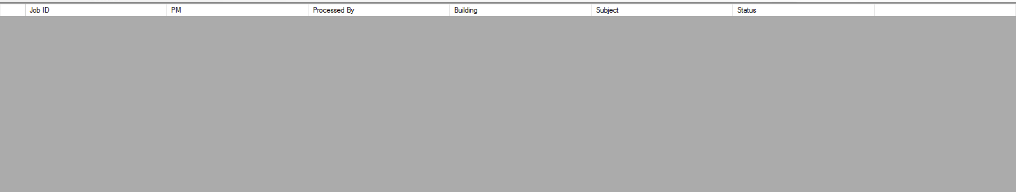

Figure 45: Job List

## 5.3) Web Maintenance:

|  |  |  |
| --- | --- | --- |
| Input: | Sample: | Notes: |
| Select Category: | Building Folders |  |
| Select Folder: | Root |  |
| Create New Folder: |  |  |
| No Image: | Select/Deselect |  |
| No Conduct Rules: |  |  |
| No Insurance Information: | Select/Deselect |  |
| No Meeting Minutes: | Select/Deselect |  |
| No Meeting Notices: | Select/Deselect |  |
| No Plans: | Select/Deselect |  |
| No Financials: | Select/Deselect |  |
| Financial Statements: | Select/Deselect |  |
| Conduct Rules: | Select/Deselect |  |
| Insurance Information: | Select/Deselect |  |
| Meeting Minutes: | Select/Deselect |  |
| Plans: | Select/Deselect |  |
| Other Files: | Select/Deselect |  |

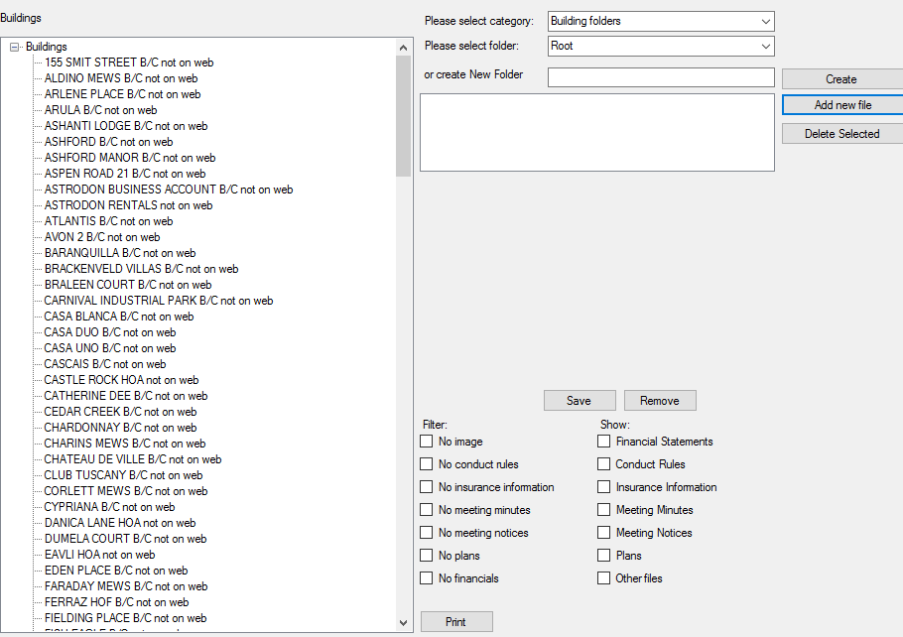

Figure 46: Web Maintenance

## 5.4) Bulk Email:

|  |  |  |
| --- | --- | --- |
| Input: | Sample: | Notes: |
| Select Building: | 155 SMIT STREET B/C |  |
| Upload Documents To: |  |  |
| Mark As Urgent: | Select/Deselect |  |
| Include All Customers: | Select/Deselect |  |
| Trustees Only: | Select/Deselect |  |
| BCC: | [Pm2@astrodon.co.za](mailto:Pm2@astrodon.co.za); [sheldon@astrodon.co.za](mailto:sheldon@astrodon.co.za) |  |
| Subject: |  |  |
| Message: |  |  |
| Attachments: |  |  |
| Bill: |  |  |

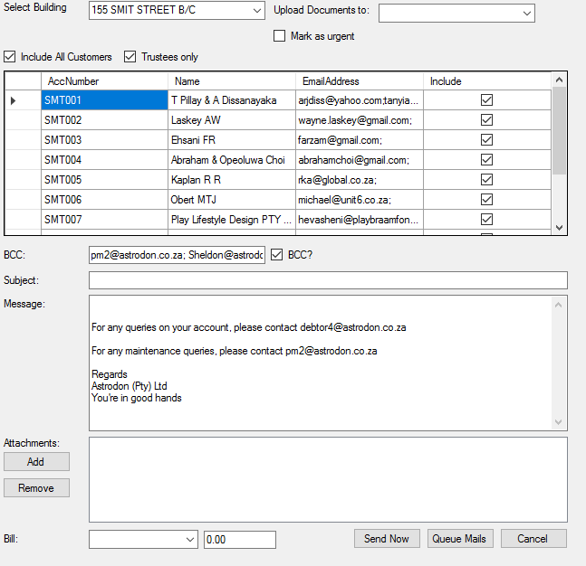

Figure 47: Bulk Email

## 5.5) Management Report:

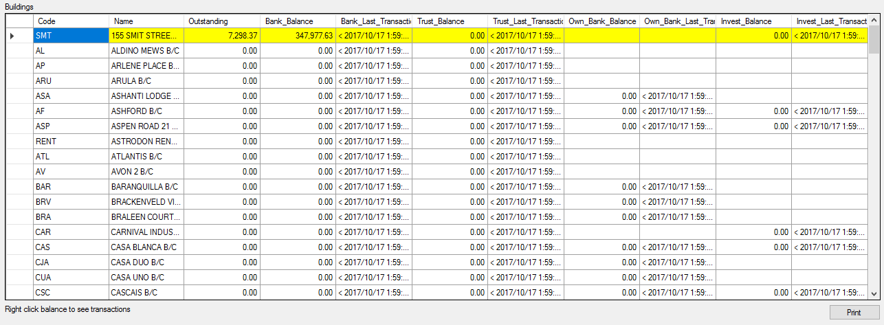

Figure 48: Management Report

## 5.6) Requisitions:

### Payment Requisitions

The section below is for loading of new requisitions for processing.

|  |  |  |
| --- | --- | --- |
| Input: | Sample: | Notes: |
| Select Date: | 2017/01/01 |  |
| Select Building: | 155 SMIT STREET B/C |  |
| Select Account: | TRUST |  |
| Select Supplier: | Astrodon Pty Ltd |  |
| Banking Details: | ABSA (123)  123123123 |  |
| Payment Notification: | [info@astrodon.co.za](mailto:info@astrodon.co.za) |  |
| Select Ledger Account: | 1000000: Levies Received |  |
| Enter Supplier Reference: | Reference on supplier invoice |  |
| Enter Amount: | Amount on supplier invoice |  |
| Invoice Number: | Invoice number of supplier invoice |  |
| Invoice Date: | 2017/01/01 |  |

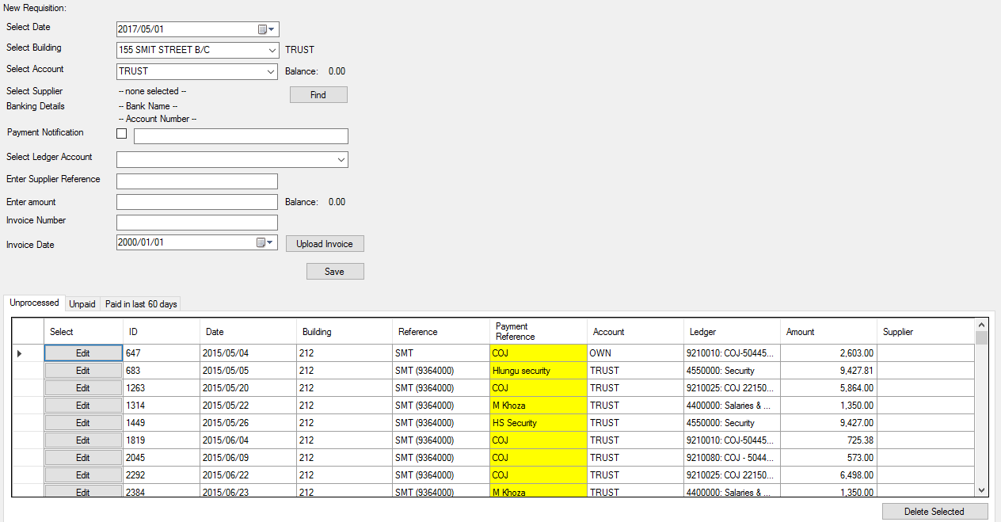

Figure 49: Payment Requisitions - Unprocessed

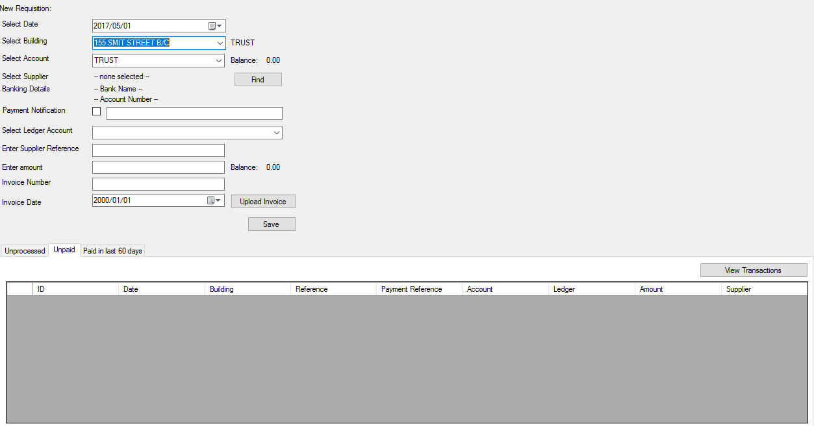

Figure 50: Payment Requisitions - Unpaid

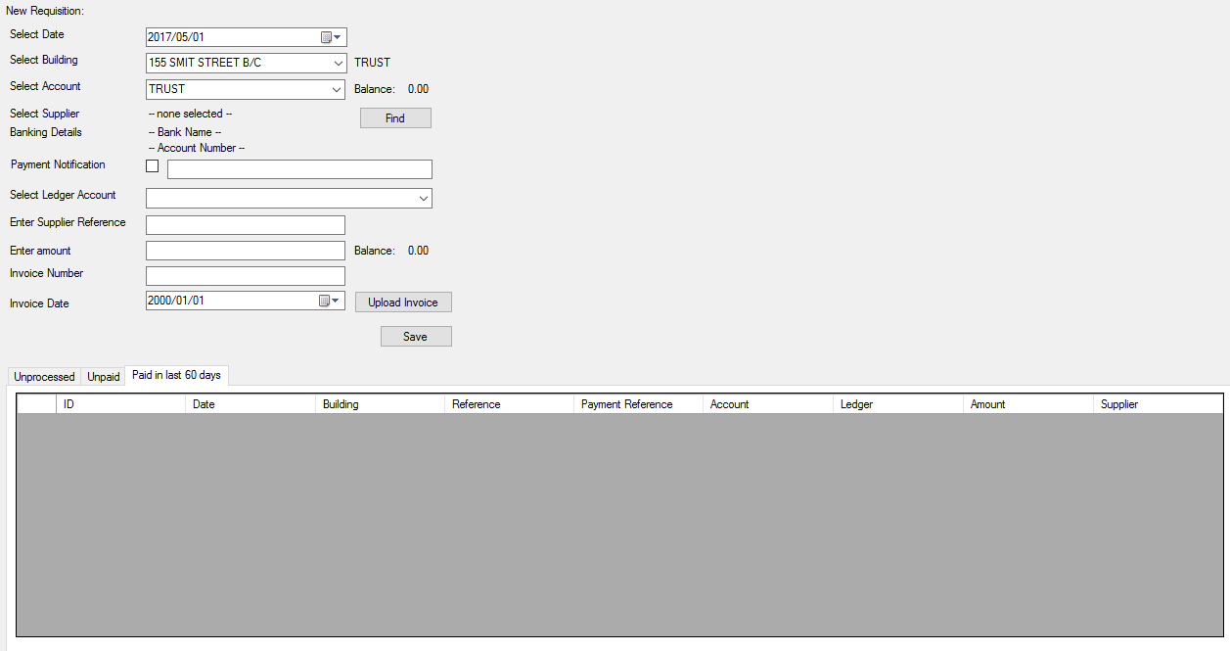

Figure 51: Payment Requisitions - Paid In Last 60 Days

### Requisition Log

The requisition log will show a list of requisitions loaded for a building.

|  |  |  |
| --- | --- | --- |
| Input: | Sample: | Notes: |
| Select Building: | 155 SMIT STREET B/C |  |

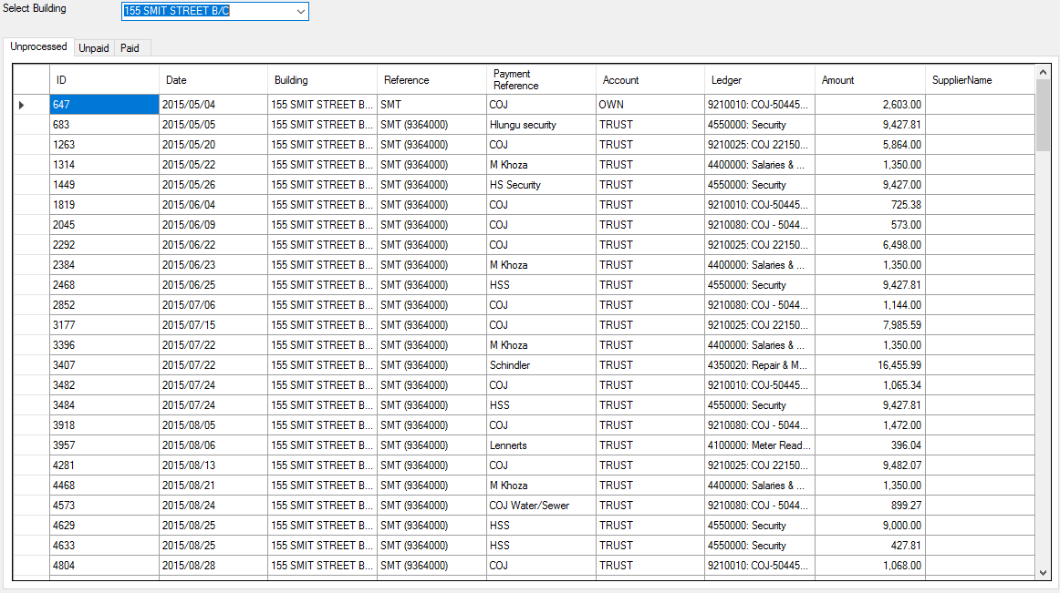

Figure 52: Requisition Log - Unprocessed

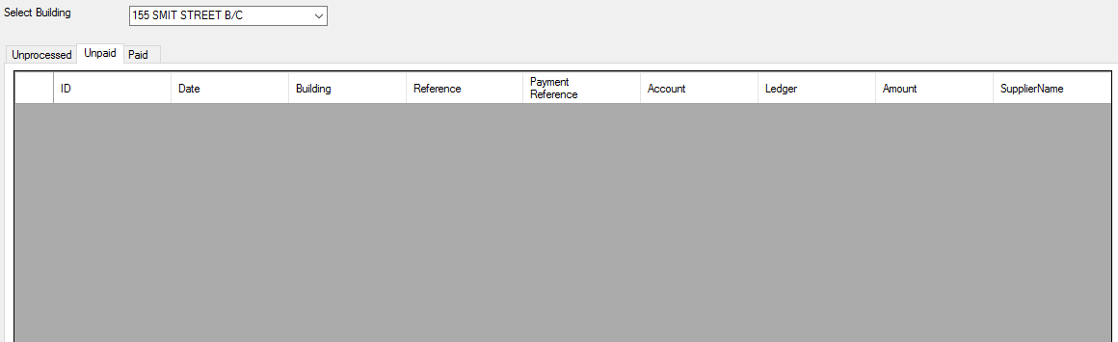

Figure 53: Requisition Log - Unpaid

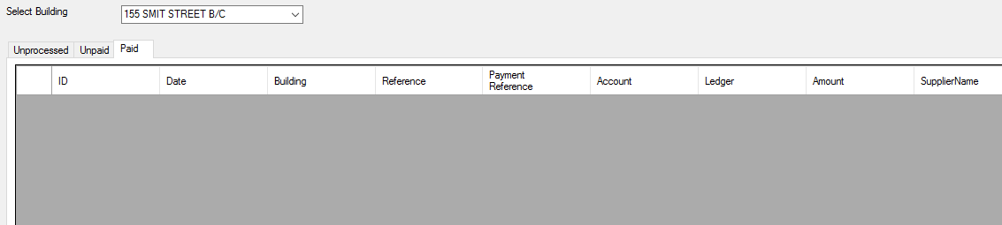

Figure 54: Requisition Log - Paid

### Missing Maintenance Requisitions

This report will display a list of requisitions against maintenance contracts which does not have a corresponding maintenance record loaded.

|  |  |  |
| --- | --- | --- |
| Input: | Sample: | Notes: |
| Select Building: | 155 SMIT STREET B/C |  |
| Date: | 2016/12/12 |  |
| Ledger: | 4350020:Repair Maint Lift Maint |  |
| Amount: | 2.386.95 |  |
| Type: | OWN |  |
| Select Supplier: | Anton’s Plumbing Solutions |  |
| Banking Details: | ABSA (6666)  666666666 |  |
| Enter Supplier Reference: | 90776822 |  |
| Invoice Number |  |  |
| Invoice Date: | 2000/01/01 |  |

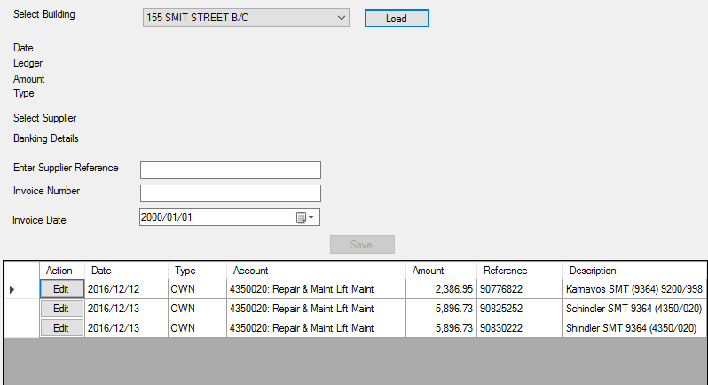

Figure 55: Missing Maintenance Requisitions

### Supplier Bulk Requisition

Allows loading of bulk requisitions for a specific supplier. Requisitions are loaded per building.

|  |  |  |
| --- | --- | --- |
| Input: | Sample: | Notes: |
| Select Date: | 2018/01/22 |  |
| Select Supplier: | Anton’s Plumbing Solutions |  |
| Default Ledger Account: | 1000000: Levies Received |  |
| Default Invoice Date: | 2000/01/01 |  |
| Default Bank Account: | ABSA: 11234561 |  |

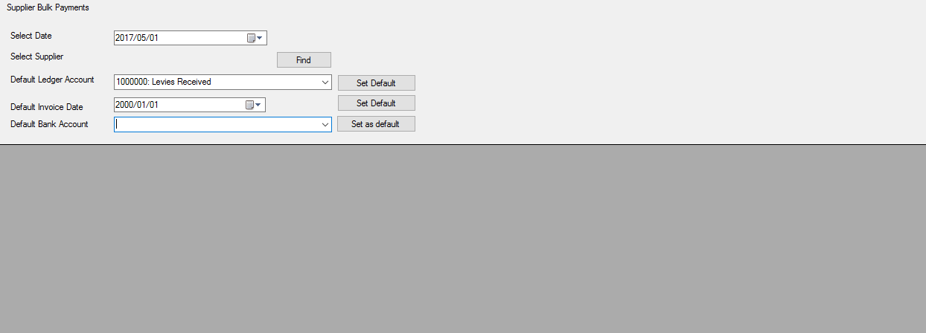

Figure 56: Supllier Bulk Requisition

|  |  |  |
| --- | --- | --- |
| Input: | Sample: | Notes: |
| Company Name: | Astrodon PTY LTD |  |
| Company Reg#: | 2004/003502/07 |  |
| Contact Person: | Sheldon Terry |  |
| Contact Number: | 0118673183 |  |

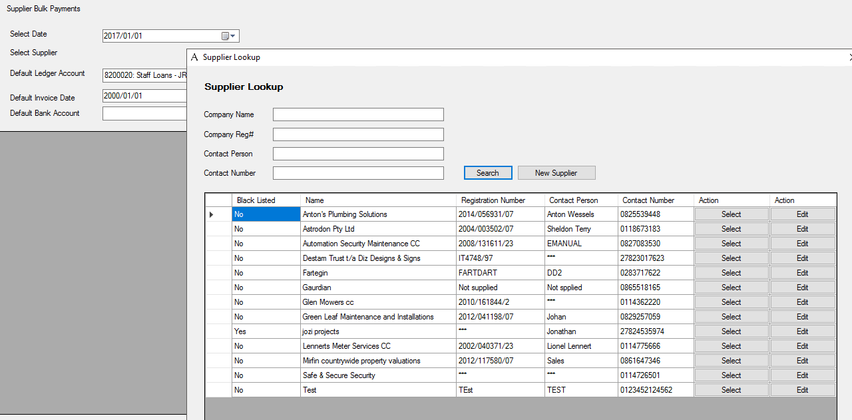

Figure 57: Supplier Bulk Requisition - Find Supplier

|  |  |  |
| --- | --- | --- |
| Input: | Sample: | Notes: |
| Company Name: | Astrodon Pty Ltd |  |
| Company Reg#: | 2004/003502/07 |  |
| VAT Number: | 4640212538 |  |
| Contact Person: | Sheldon Terry |  |
| Email Address: | [info@astrodon.co.za](mailto:info@astrodon.co.za) |  |
| Contact Number: | 0118673183 |  |
| Black Listed: | Select/Deselect |  |
| Reason: |  |  |
| Building: | 155 SMIT STREET B/C |  |
| Bank: | ABSA |  |
| Branch: | ABSA |  |
| Branch Code: | 123 |  |
| Account Number: | 123123123 |  |

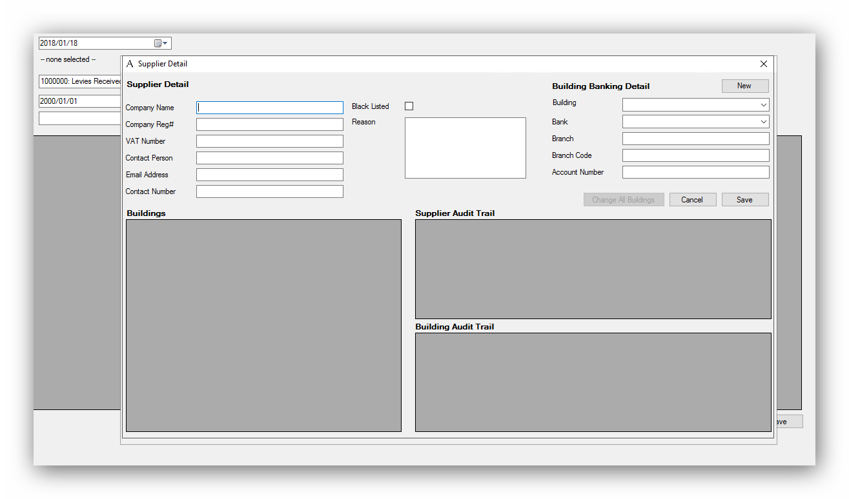

Figure 58: Supplier Bulk Requisition - New Supplier

### Download Requisition Batch

Processing and batching of requisitions at the end of the day for payment.

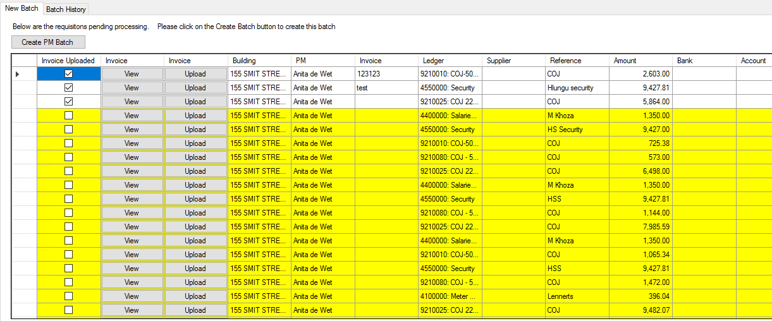

Figure 59: Download Requisition Batch - New Batch

|  |  |  |
| --- | --- | --- |
| Input: | Sample: | Notes: |
| Select Building: | 155 SMIT STREET B/C |  |

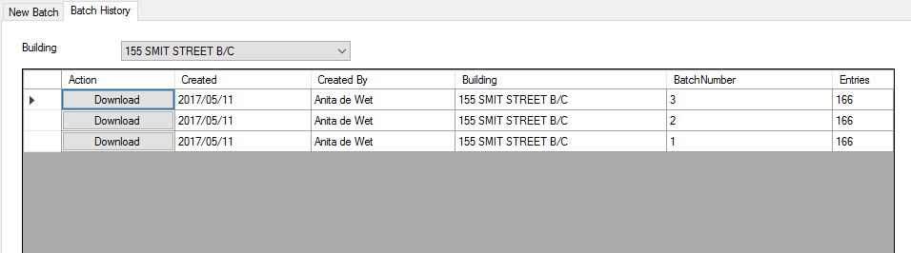

Figure 60: Download Requisition Batch - Batch History

### Unpaid Requisitions

Displays a list of unpaid requisitions.

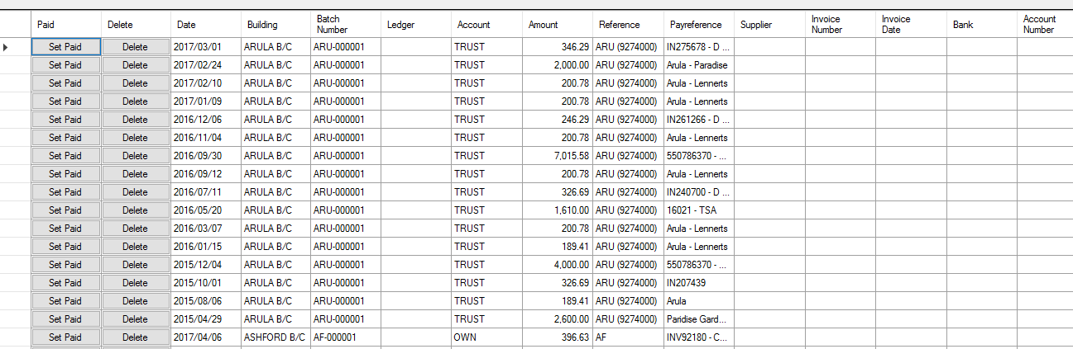

Figure 61: Unpaid Requisitions

### Nedbank Beneficiary Maintenance:

Maintain a list of beneficiaries payable via Nedbank debit order.

|  |  |  |
| --- | --- | --- |
| Input: | Sample: | Notes: |
| Building: | 155 SMIT STREET B/C |  |
| Show All Suppliers: | Select/Deselect |  |

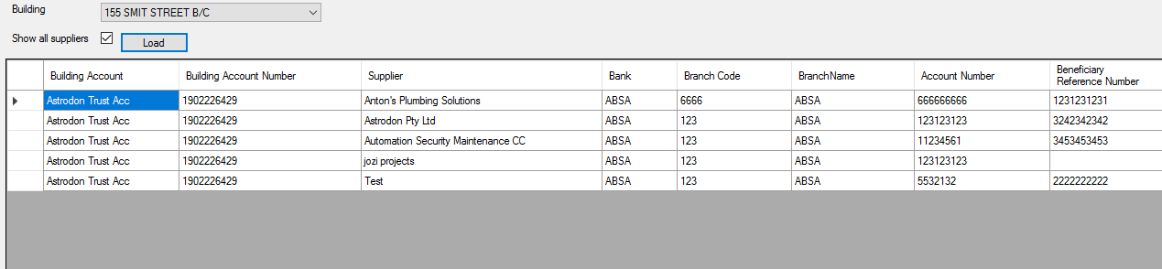

Figure 62: Nedbank Beneficiary Maintenance

## 5.7) Building Maintenance:

|  |  |  |
| --- | --- | --- |
| Input: | Sample: | Notes: |
| Select Building: | 155 SMIT STREET B/C |  |
| From Date: | 2017/01/01 |  |
| To Date: | 2018/01/01 |  |
| Unlinked Only: | Select/Deselect |  |

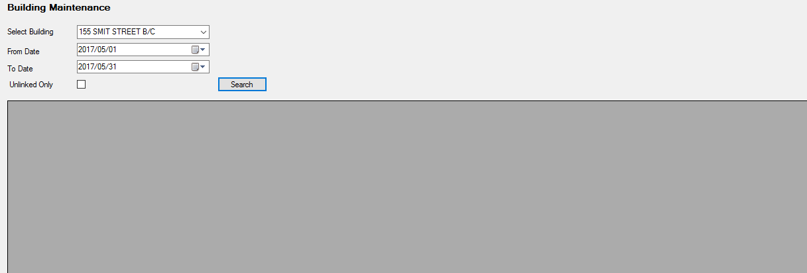

Figure 63: Building Maintenance

## 5.8) Supplier Maintenance:

|  |  |  |
| --- | --- | --- |
| Input: | Sample: | Notes: |
| Company Name: | Astrodon Pty Ltd |  |
| Company Reg# | 2004/003502/07 |  |
| Contact Person: | Sheldon Terry |  |
| Contact Number: | 0118673183 |  |

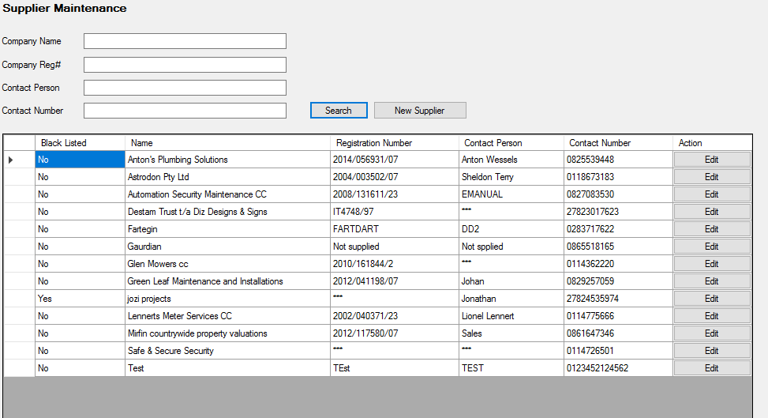

Figure 64: Supplier Maintenance

|  |  |  |
| --- | --- | --- |
| Input: | Sample: | Notes: |
| Company Name: | RTMSoft |  |
| Company Reg #: | 2005/008650/09 |  |
| VAT Number: | 5976102486 |  |
| Contact Person: | Rochelle van der Merwe |  |
| Email Address: | [rochelle@rtmsoft.co.za](mailto:rochelle@rtmsoft.co.za) |  |
| Contact Number: | 0749685861 |  |
| Black Listed: | Select/Deselect |  |
| Reason: | If yes, Give reasons |  |
| Building: | 168 KRUGER AVE |  |
| Bank: | Capitec |  |
| Branch: | Capitec |  |
| Branch Code: | 185 |  |
| Account Number: | 794586000 |  |

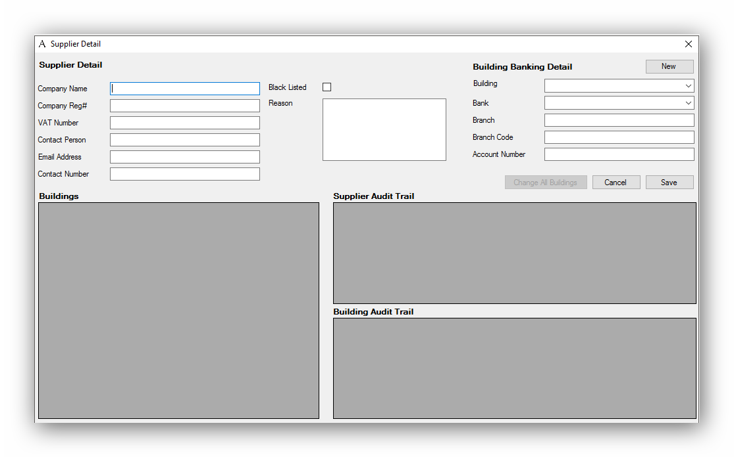

Figure 65: Supplier Maintenance - New Supplier

## 5.9) Insurance Broker Maintenance:

|  |  |  |
| --- | --- | --- |
| Input: | Sample: | Notes: |
| Company Name: | Santam 22 |  |
| Company Reg#: | 123123123 |  |
| Contact Person: | Santma Willem Malerbe |  |
| Contact Number: | 0828833761 |  |

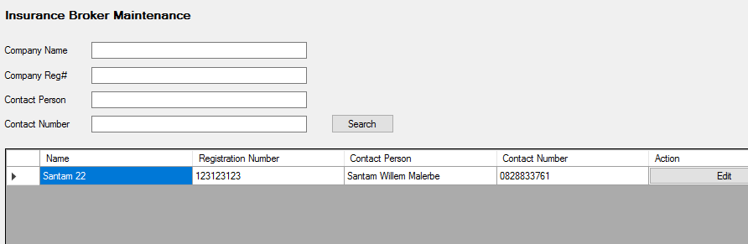

Figure 66: Insurance Broker Maintenance

# 6: Debtors Reports

## 6.1) Debtors Report:

|  |  |  |
| --- | --- | --- |
| Input: | Sample: | Notes: |
| Select Date: | 2018/05/01 |  |

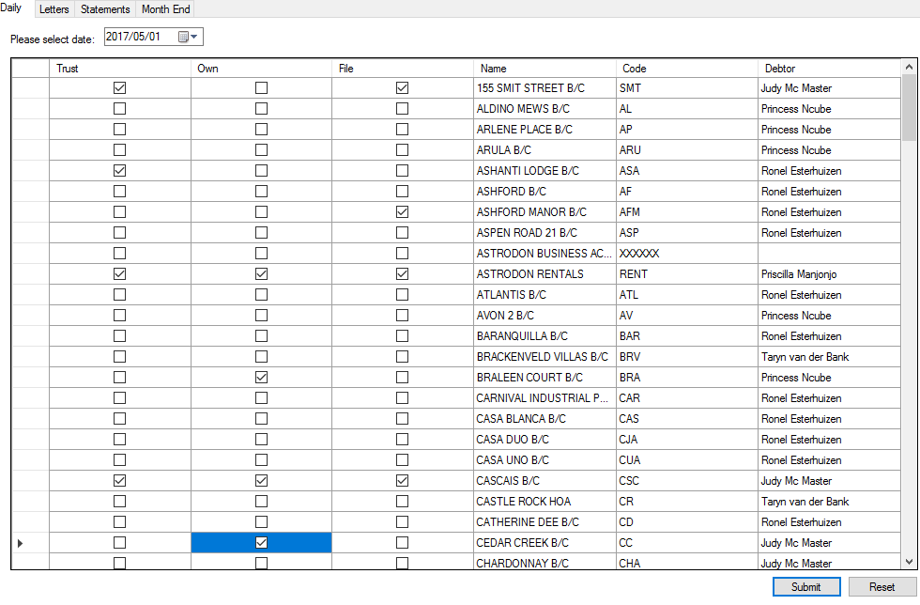

Figure 67: Debtors Report - Daily

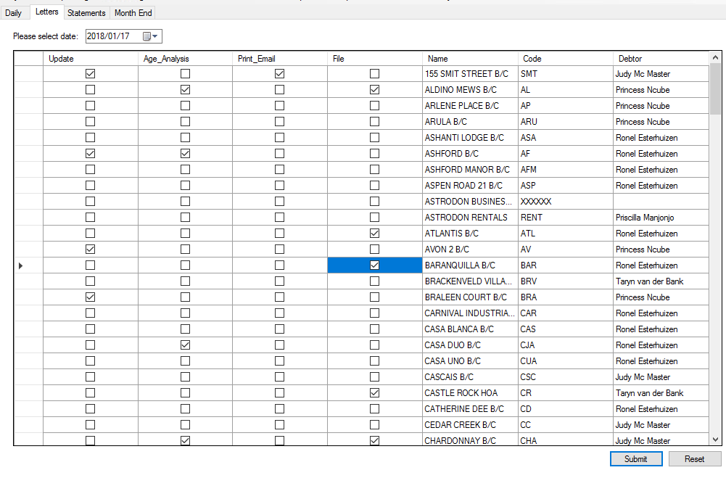

Figure 68: Debtors Report - Letters

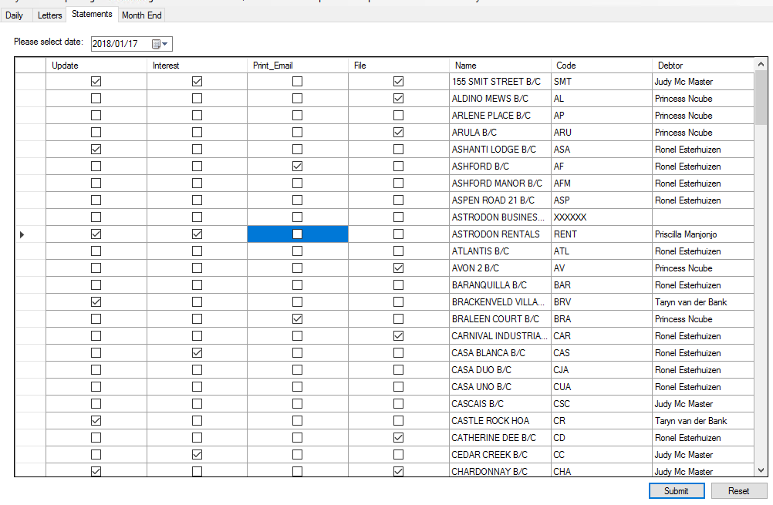

Figure 69: Debtors Report - Statements

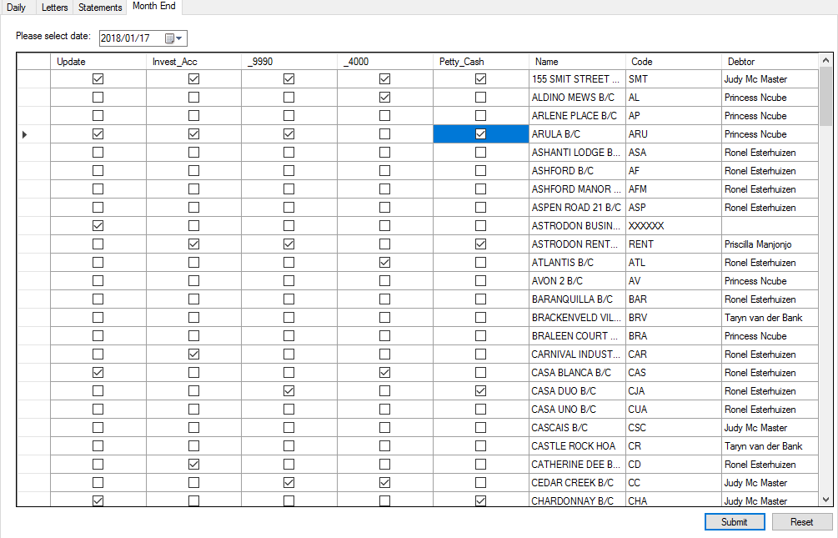

Figure 70: Debtors Report - Month End

## 6.2) Consolidated Debtors Report:

|  |  |  |
| --- | --- | --- |
| Input: | Sample: | Notes: |
| Filter By Debtor: | Select From Dropdown |  |

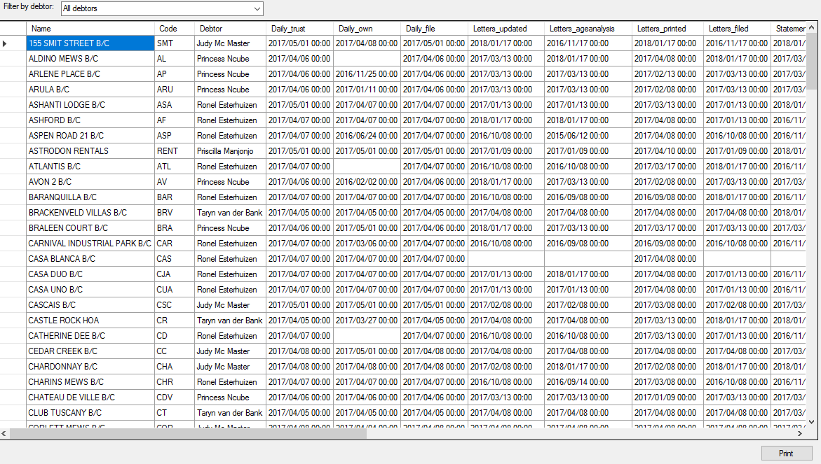

Figure 71: Consolidated Debtors Report

# 7: Reminders

This is where all your listed Reminders will come up. The Reminders Icon will be flashing red the whole time.

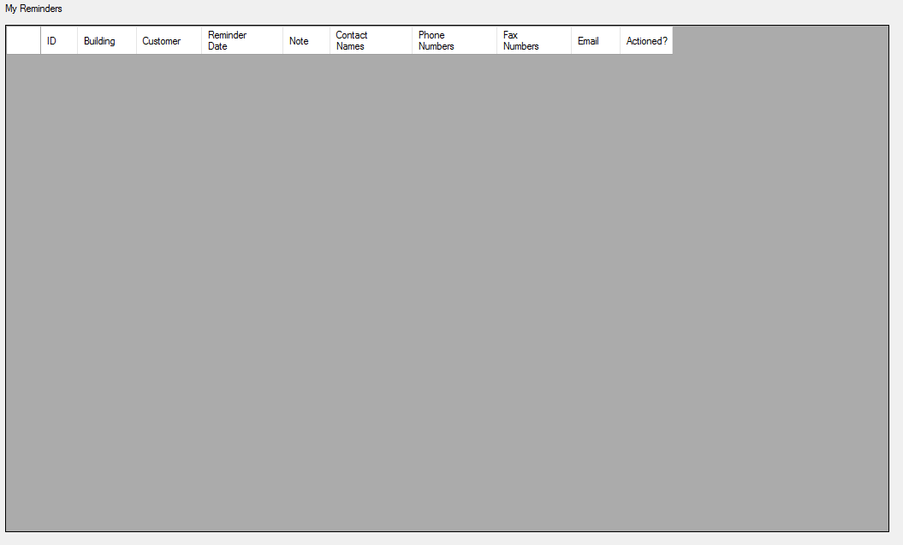

Figure 72: Reminders

# 8: Monthly Financials

## 8.1) Checklist:

|  |  |  |
| --- | --- | --- |
| Input: | Sample: | Notes: |
| Levies Received: | Select/Deselect |  |
| Domestic Effluent Recoveries: | Select/Deselect |  |
| Electricity Recoveries: | Select/Deselect |  |
| Water Recoveries: | Select/Deselect |  |
| Special Levies: | Select/Deselect |  |
| Any Other Income Accounts To Be Noted: | Select/Deselect |  |
| Interest From Members: | Select/Deselect |  |
| Interest From Bank Investments: | Select/Deselect |  |
| Comments: | Any Additional Comments |  |

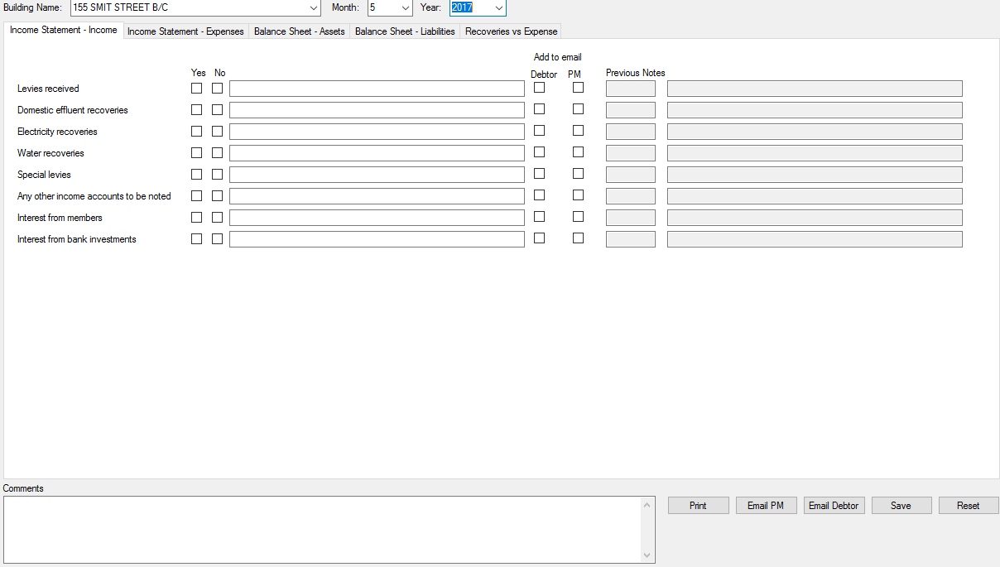

Figure 73: Checklist - Income Statement – Income

|  |  |  |
| --- | --- | --- |
| Input: | Sample: | Notes: |
| Accounting Fees: | Select/Deselect |  |
| Bank Charges: | Select/Deselect |  |
| Domestic Effluent: | Select/Deselect |  |
| Deliveries: | Select/Deselect |  |
| Electricity: | Select/Deselect |  |
| Gardens: | Select/Deselect |  |
| Insurance: | Select/Deselect |  |
| Interest Paid (Why&Reason): | Select/Deselect |  |
| Management Fees: | Select/Deselect |  |
| Meter Reading Fees: | Select/Deselect |  |
| Printing & Stationery: | Select/Deselect |  |
| Post & Petties: | Select/Deselect |  |
| Repairs & Maintenance: | Select/Deselect |  |
| Refuse Removal: | Select/Deselect |  |
| Salaries & Wages: | Select/Deselect |  |
| Security: | Select/Deselect |  |
| Telephone: | Select/Deselect |  |
| Water: | Select/Deselect |  |
| Comments: | Any Additional Information |  |

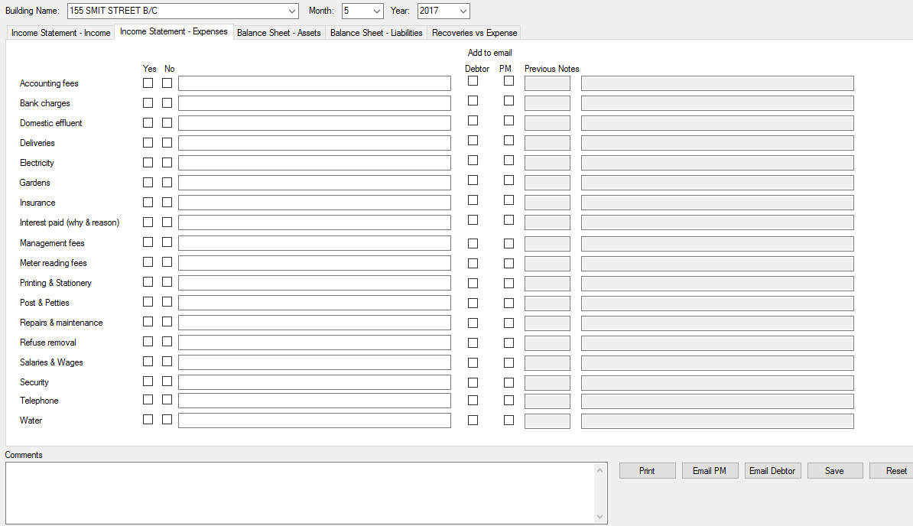

Figure 74: Checklist - Income Statement – Expenses

|  |  |  |
| --- | --- | --- |
| Input: | Sample: | Notes: |
| Municipal Deposit Verified Against Council Statement: |  |  |
| Trust Account Balance Verified: |  |  |
| Own Account Balance Verified Against Statement: |  |  |
| Sundry Accruals Verified: |  |  |
| Any Other Assets To Be Noted: |  |  |
| Comments: |  |  |

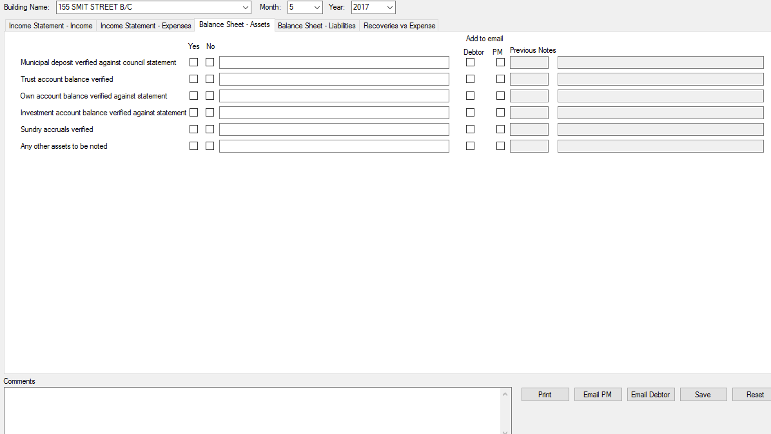

Figure 75: Checklist - Balance Sheet – Assets

|  |  |  |
| --- | --- | --- |
| Input: | Sample: | Notes: |
| Verification Of Debtors: | Select/Deselect |  |
| Verification Of Municipal Accounts – All Payments Reflect: | Select/Deselect |  |
| Verification Of Owners Deposits Note Any Changes: | Select/Deselect |  |
| Sundry Suppliers Verified: | Select/Deselect |  |
| Any Other Liabilities To Be Noted: | Select/Deselect |  |
| Comments: | Any Additional Information |  |

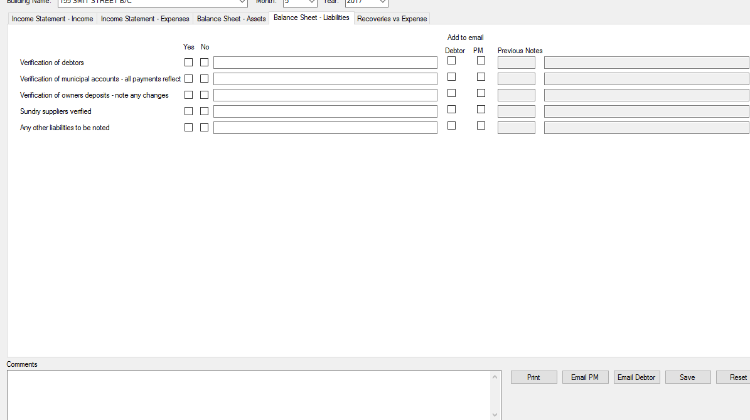

Figure 76: Checklist - Balance Sheet – Liabilities

|  |  |  |
| --- | --- | --- |
| Input: | Sample: | Notes: |
| Electricity: | Under Recovery/Over Recovery/In Line |  |
| Water: | Under Recovery/Over Recovery/In Line |  |
| Comments: | Additional Information |  |

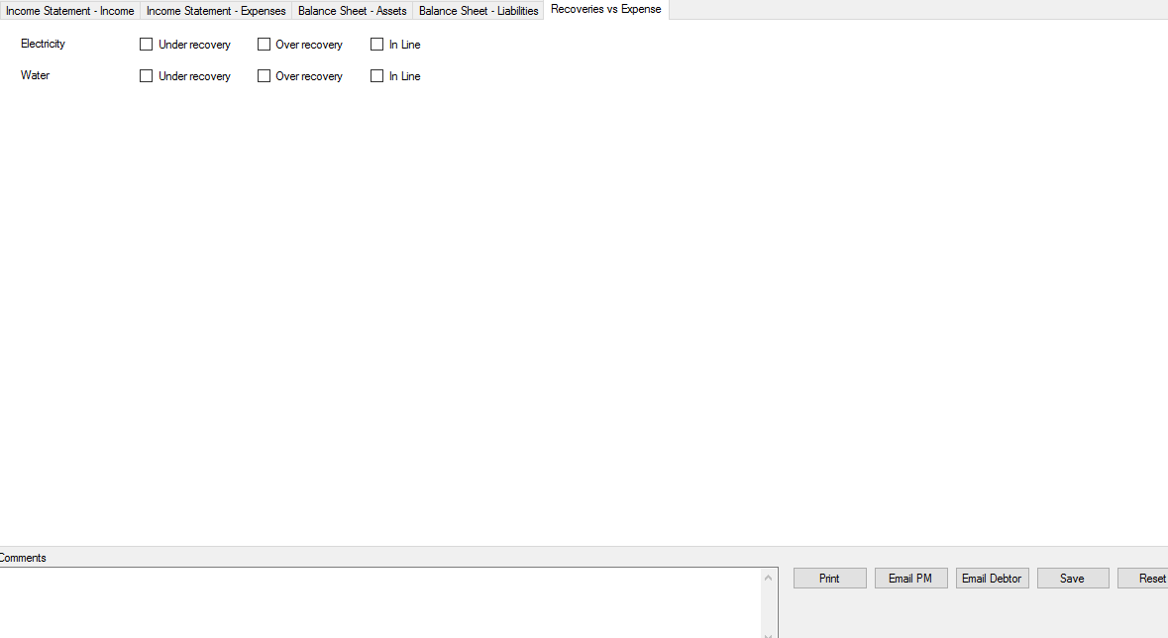

Figure 77: Checklist - Recoveries vs Expenses

## 8.2) Report:

|  |  |  |
| --- | --- | --- |
| Input: | Sample: | Notes: |
| Year: | 2017 |  |
| Month: | January |  |
| User: | Anita de Wet |  |
| Complete/Incomplete: | Select/Deselect |  |

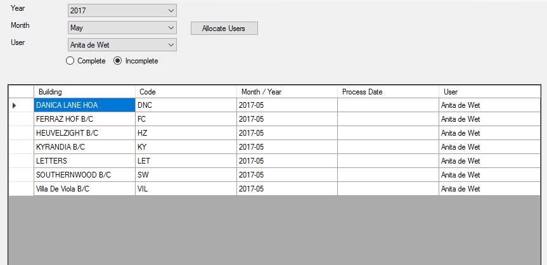

Figure 78: Report

## 8.3) Request Allocations:

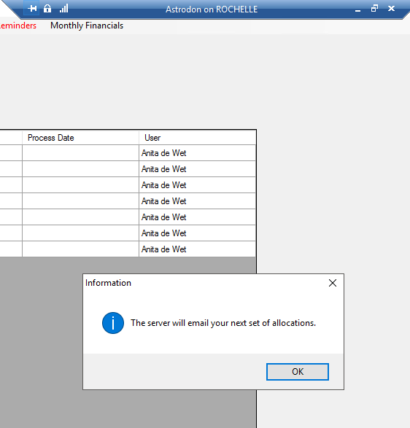

Figure 79: Request Allocations

## 8.4) Levy Roll:

|  |  |  |
| --- | --- | --- |
| Input: | Sample: | Notes: |
| Year: | 2017 |  |
| Month: | January |  |
| Building: | 155 SMIT STREET B/C |  |
| Include Sundries: | Select/Deselect |  |

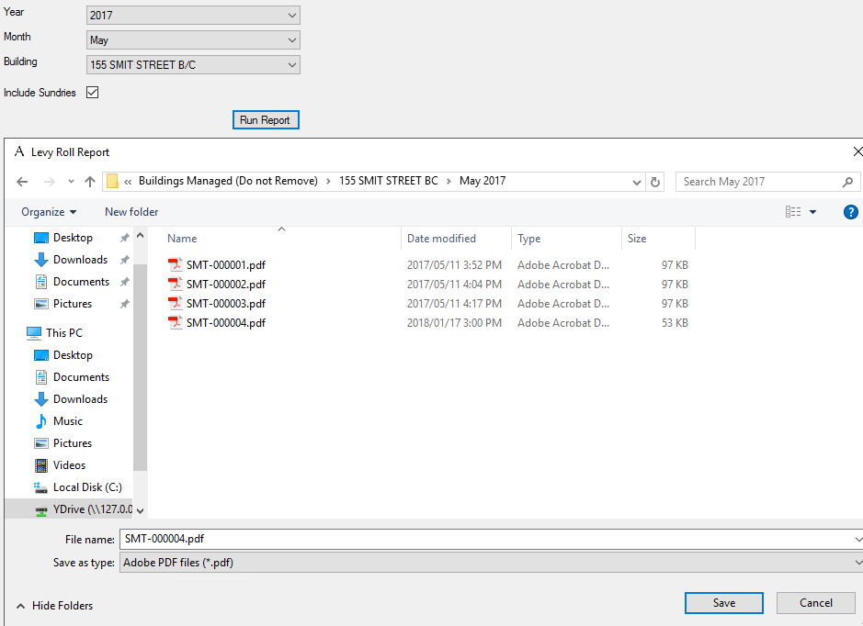

Figure 80: Levy Roll

## 8.5) Management Pack:

|  |  |  |
| --- | --- | --- |
| Input: | Sample: | Notes: |
| Year: | 2017 |  |
| Building: | 155 SMIT STREET B/C |  |
| Month: | January |  |
| Include Sundries: | Select/Deselect |  |
| Summary Report/Detailed Report/Detailed Report With Supporting Documents: | Select/Deselect |  |

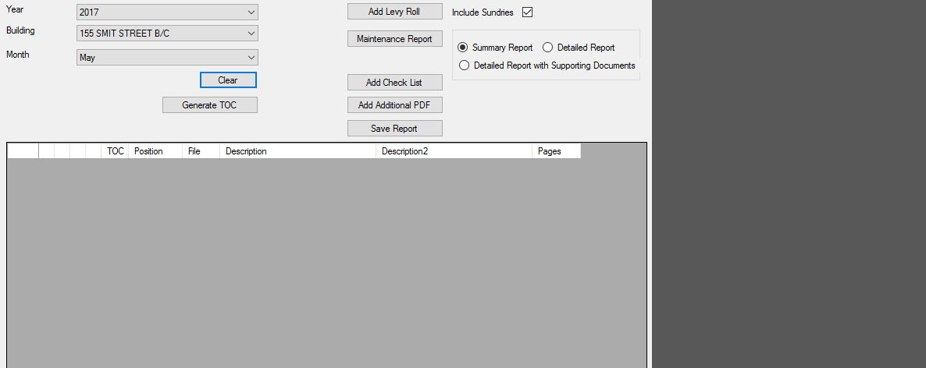

Figure 81: Management Pack

## 8.6) Publish Management Pack:

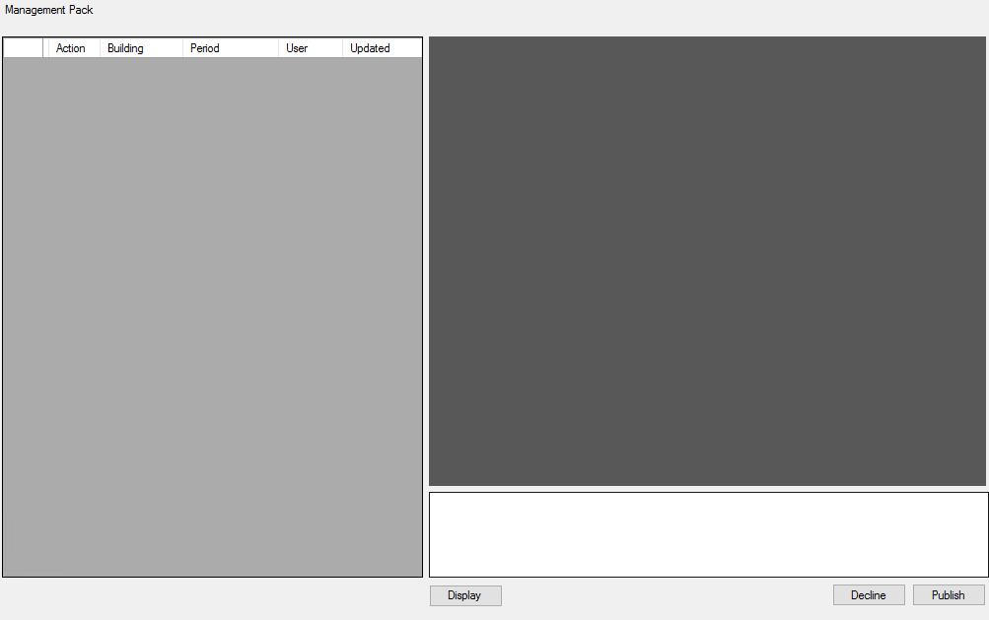

Figure 82: Publish Management Pack

## 8.7) Calendar:

|  |  |  |
| --- | --- | --- |
| Input: | Sample: | Notes: |
| Year: | 2018 |  |
| Month: | January |  |
| Meeting Type: | Financial/Staff |  |
| Filter By PM: | Select/Deselect |  |
| From: | 2018/01/01 8:00:00AM |  |
| To: | 2018/01/01 8:15:00AM |  |
| Building: | 155 SMIT STREET B/C |  |
| Notify Trustees: | Select/Deselect |  |
| Event: |  |  |
| Venue: |  |  |
| BCC: |  |  |
| Invite Subject: |  |  |
| Invite Body Content: |  |  |

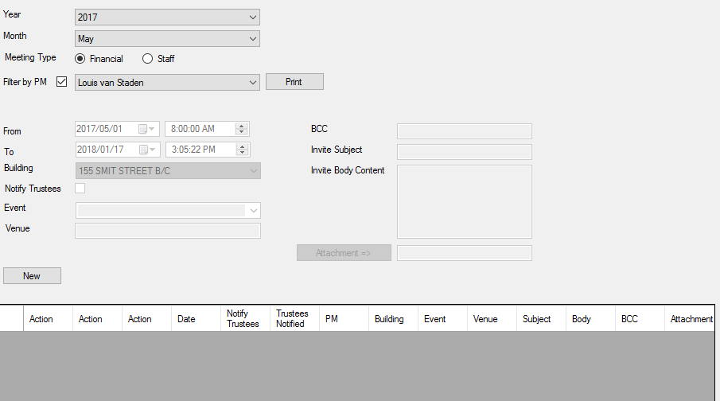

Figure 83: Calendar

## 